1. **Implement the following Simple Servlet applications.**
   1. Create a simple calculator application using servlet.

Index.html

<!DOCTYPE html>

<!--

To change this license header, choose License Headers in Project Properties.

To change this template file, choose Tools | Templates

and open the template in the editor.

-->

<html>

<head>

<meta charset="UTF-8">

<meta name="viewport" content="width=device-width, initial-scale=1.0">

<title> Calculator</title>

</head>

<body>

<h1>Simple Calculator</h1>

<form action="Ans">

<input type="text" name="num1" placeholder="Operator1">

<select name="op">

<option value="+">+</option>

<option value="-">-</option>

<option value="*">*</option>

<option value="/">/</option>

</select>

<input type="text" name="num2" placeholder="Operator2">

<br>

<input type="submit" value="Calculate Result">

</form>

</body>

</html>

o/p

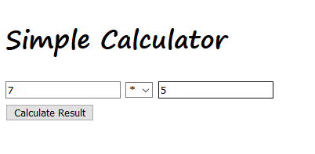

Ans.java

/*

* To change this license header, choose License Headers in Project Properties.

* To change this template file, choose Tools | Templates

* and open the template in the editor.

*/

import java.io.IOException;

import java.io.PrintWriter;

import javax.servlet.ServletException;

import javax.servlet.annotation.WebServlet;

import javax.servlet.http.HttpServlet;

import javax.servlet.http.HttpServletRequest;

import javax.servlet.http.HttpServletResponse;

/**

*

* @author H310MS2

*/

@WebServlet(urlPatterns = {"/NewServlet"})

public class Ans extends HttpServlet {

/**

* Processes requests for both HTTP <code>GET</code> and <code>POST</code>

* methods.

*

* @param request servlet request

* @param response servlet response

* @throws ServletException if a servlet-specific error occurs

* @throws IOException if an I/O error occurs

*/

protected void processRequest(HttpServletRequest request, HttpServletResponse response)

throws ServletException, IOException {

double d1 = Double.parseDouble(request.getParameter("num1"));

double d2 = Double.parseDouble(request.getParameter("num2"));

double ans=0;

response.setContentType("text/html;charset=UTF-8");

try (PrintWriter out = response.getWriter()) {

/* TODO output your page here. You may use following sample code. */

out.println("<!DOCTYPE html>");

out.println("<html>");

out.println("<head>");

out.println("<title>Servlet NewServlet</title>");

out.println("</head>");

out.println("<body>");

switch(request.getParameter("op"))

{

case "+":

ans=d1+d2;

break;

case "-":

ans=d1-d2;

break;

case "*":

ans=d1*d2;

break;

case "/":

ans=d1/d2;

break;

}

out.println("<h1> Result = " + ans + " </h1>");

out.println("</body>");

out.println("</html>");

}

} // <editor-fold defaultstate="collapsed" desc="HttpServlet methods. Click on the + sign on the left to edit the code.">

/**

* Handles the HTTP <code>GET</code> method.

*

* @param request servlet request

* @param response servlet response

* @throws ServletException if a servlet-specific error occurs

* @throws IOException if an I/O error occurs

*/

@Override

protected void doGet(HttpServletRequest request, HttpServletResponse response)

throws ServletException, IOException {

processRequest(request, response);

}

/**

* Handles the HTTP <code>POST</code> method.

*

* @param request servlet request

* @param response servlet response

* @throws ServletException if a servlet-specific error occurs

* @throws IOException if an I/O error occurs

*/

@Override

protected void doPost(HttpServletRequest request, HttpServletResponse response)

throws ServletException, IOException {

processRequest(request, response);

}

/**

* Returns a short description of the servlet.

*

* @return a String containing servlet description

*/

@Override

public String getServletInfo() {

return "Short description";

}// </editor-fold>

}

o/p

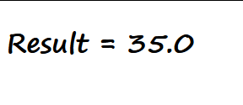

--------------------------------------------------------------------------------------------------------------------------------------

* 1. Create a servlet for a login page. If the username and password are correct, then it says message “Hello <username>” else a message “login failed”.

Index.html

<!DOCTYPE html>

<html>

<head>

<title>Start Page</title>

<meta http-equiv="Content-Type" content="text/html; charset=UTF-8">

</head>

<body>

<form action="Login_static" method="get">

Enter User ID: <input type="text" name="txtName"><br>

Enter Password: <input type="password" name="pass"><br>

<input type="reset"><input type="submit">

</form>

</body>

</html>

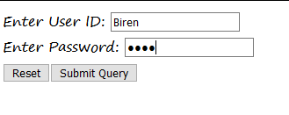

Login_Static.java

/*

* To change this license header, choose License Headers in Project Properties.

* To change this template file, choose Tools | Templates

* and open the template in the editor.

*/

import java.io.IOException;

import java.io.PrintWriter;

import javax.servlet.RequestDispatcher;

import javax.servlet.ServletException;

import javax.servlet.http.HttpServlet;

import javax.servlet.http.HttpServletRequest;

import javax.servlet.http.HttpServletResponse;

/**

*

* @author H310MS2

*/

public class Login_static extends HttpServlet {

/**

* Processes requests for both HTTP <code>GET</code> and <code>POST</code>

* methods.

*

* @param request servlet request

* @param response servlet response

* @throws ServletException if a servlet-specific error occurs

* @throws IOException if an I/O error occurs

*/

protected void processRequest(HttpServletRequest request, HttpServletResponse response)

throws ServletException, IOException {

{

response.setContentType("text/html;charset=UTF-8");

try (PrintWriter out = response.getWriter()) {

/* TODO output your page here. You may use following sample code. */

out.println("<body>");

String uname= request.getParameter("txtName");

String upass= request.getParameter("pass");

if(uname.equals("Biren") && upass.equals("java"))

{

RequestDispatcher rd = request.getRequestDispatcher("Welcome");

rd.forward(request, response);

}

else{

out.println("<body >");

out.println("<font color=red><h1> Login Fail !!! </h1></font");

RequestDispatcher rd= request.getRequestDispatcher("index.html");

rd.include(request, response);

}

out.println("</body>");

}

}

}

// <editor-fold defaultstate="collapsed" desc="HttpServlet methods. Click on the + sign on the left to edit the code.">

/**

* Handles the HTTP <code>GET</code> method.

*

* @param request servlet request

* @param response servlet response

* @throws ServletException if a servlet-specific error occurs

* @throws IOException if an I/O error occurs

*/

@Override

protected void doGet(HttpServletRequest request, HttpServletResponse response)

throws ServletException, IOException {

processRequest(request, response);

}

/**

* Handles the HTTP <code>POST</code> method.

*

* @param request servlet request

* @param response servlet response

* @throws ServletException if a servlet-specific error occurs

* @throws IOException if an I/O error occurs

*/

@Override

protected void doPost(HttpServletRequest request, HttpServletResponse response)

throws ServletException, IOException {

processRequest(request, response);

}

/**

* Returns a short description of the servlet.

*

* @return a String containing servlet description

*/

@Override

public String getServletInfo() {

return "Short description";

}// </editor-fold>

}



--------------------------------------------------------------------------------------------------------------------------------------

* 1. Create a registration servlet in Java using JDBC. Accept the details such as Username, Password, Email, and Country from the user using HTML Form and store the registration details in the database.

Index.html

Top of Form

<!DOCTYPE html>

<!--

To change this license header, choose License Headers in Project Properties.

To change this template file, choose Tools | Templates

and open the template in the editor.

-->

<html>

<head>

<title>Java DataBase Connectivity</title>

<meta charset="UTF-8">

<meta name="viewport" content="width=device-width, initial-scale=1.0">

</head>

<body>

<h1> Registration from</h1>

<form action="jdbc “>

Enter User Name: <input type=”text” name=”txtUser”><br>

Enter Password: <input type=”password” name=”txtPass”><br>

Enter Email Address:<input type=”text” name=”txtEmail”><br>

Enter Your Country:<input type=”text” name=”txtCoun” ><br>

<input type=”reset” value=”Clear”>

<input type=”submit” value=”Register” >

</form>

</body>

</html>

o/p

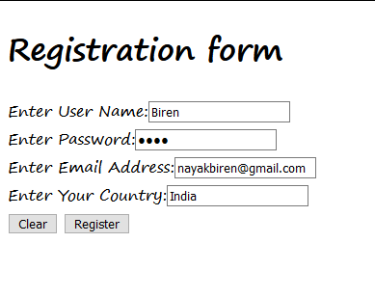

Jdbc.java

/*

* To change this license header, choose License Headers in Project Properties.

* To change this template file, choose Tools | Templates

* and open the template in the editor.

*/

import java.io.IOException;

import java.io.PrintWriter;

import java.sql.Connection;

import java.sql.DriverManager;

import java.sql.PreparedStatement;

import javax.servlet.ServletException;

import javax.servlet.http.HttpServlet;

import javax.servlet.http.HttpServletRequest;

import javax.servlet.http.HttpServletResponse;

/**

*

* @author H310MS2

*/

public class jdbc extends HttpServlet {

/**

* Processes requests for both HTTP <code>GET</code> and <code>POST</code>

* methods.

*

* @param request servlet request

* @param response servlet response

* @throws ServletException if a servlet-specific error occurs

* @throws IOException if an I/O error occurs

*/

protected void processRequest(HttpServletRequest request, HttpServletResponse response)

throws ServletException, IOException {

response.setContentType("text/html;charset=UTF-8");

try (PrintWriter out = response.getWriter()) {

/* TODO output your page here. You may use following sample code. */

out.println("<!DOCTYPE html>");

out.println("<html>");

out.println("<head>");

out.println("<title>Servlet jdbc</title>");

out.println("</head>");

out.println("<body>");

out.println("<h1>" + "Registration Status" + "</h1>");

String s1 = request.getParameter("txtUser");

String s2 = request.getParameter("txtPass");

String s3 = request.getParameter("txtEmail");

String s4 = request.getParameter("txtCoun");

try{

Class.forName("com.mysql.jdbc.Driver");

Connection con = DriverManager.getConnection("jdbc:mysql://localhost:3306/test","root","root");

PreparedStatement pst = con.prepareStatement("insert into registration_details values(?,?,?,?)");

pst.setString(1,s1);

pst.setString(2,s2);

pst.setString(3,s3);

pst.setString(4,s4);

int row = pst.executeUpdate();

if(row == 1)

out.println("<h3>"+"You have been registered sucessfully" + "</h3>");

else

out.println("<h3>"+"Registration Failed" + "</h3>");

}catch(Exception e)

{

out.println(e);

}

out.println("</body>");

out.println("</html>");

}

}

// <editor-fold defaultstate="collapsed" desc="HttpServlet methods. Click on the + sign on the left to edit the code.">

/**

* Handles the HTTP <code>GET</code> method.

*

* @param request servlet request

* @param response servlet response

* @throws ServletException if a servlet-specific error occurs

* @throws IOException if an I/O error occurs

*/

@Override

protected void doGet(HttpServletRequest request, HttpServletResponse response)

throws ServletException, IOException {

processRequest(request, response);

}

/**

* Handles the HTTP <code>POST</code> method.

*

* @param request servlet request

* @param response servlet response

* @throws ServletException if a servlet-specific error occurs

* @throws IOException if an I/O error occurs

*/

@Override

protected void doPost(HttpServletRequest request, HttpServletResponse response)

throws ServletException, IOException {

processRequest(request, response);

}

/**

* Returns a short description of the servlet.

*

* @return a String containing servlet description

*/

@Override

public String getServletInfo() {

return "Short description";

}// </editor-fold>

}

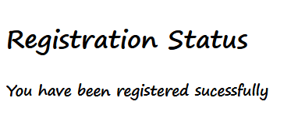

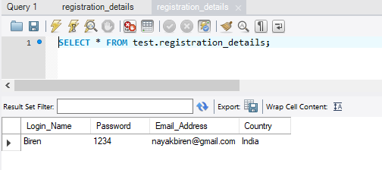

1. **Implement the following Servlet applications with Cookies and Sessions**
2. Using Request Dispatcher Interface create a Servlet which will validate the password entered by the user, if the user has entered "Servlet" as password, then he will be forwarded to Welcome Servlet else the user will stay on the index.html page and an error message will be displayed.

Index.html

<!DOCTYPE html>

<!--

To change this license header, choose License Headers in Project Properties.

To change this template file, choose Tools | Templates

and open the template in the editor.

-->

<html>

<head>

<title>TODO supply a title</title>

<meta charset="UTF-8">

<meta name="viewport" content="width=device-width, initial-scale=1.0">

</head>

<body>

<h1> Registration from</h1>

<form action="jdbc">

Enter User Name:<input type="text" name="txtUser"><br>

Enter Password:<input type="password" name="txtPass"><br>

Enter Email Address:<input type="text" name="txtEmail"><br>

Enter Your Country:<input type="text" name="txtCoun" ><br>

<input type="reset" value="Clear">

<input type="submit" value="Register" >

</form>

</body>

</html>

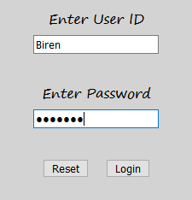

LoginServlet.java

/*

* To change this license header, choose License Headers in Project Properties.

* To change this template file, choose Tools | Templates

* and open the template in the editor.

*/

import java.io.IOException;

import java.io.PrintWriter;

import javax.servlet.RequestDispatcher;

import javax.servlet.ServletException;

import javax.servlet.http.HttpServlet;

import javax.servlet.http.HttpServletRequest;

import javax.servlet.http.HttpServletResponse;

/**

*

* @author H310MS2

*/

public class LoginServlet extends HttpServlet {

/**

* Processes requests for both HTTP <code>GET</code> and <code>POST</code>

* methods.

*

* @param request servlet request

* @param response servlet response

* @throws ServletException if a servlet-specific error occurs

* @throws IOException if an I/O error occurs

*/

protected void processRequest(HttpServletRequest request, HttpServletResponse response)

throws ServletException, IOException {

response.setContentType("text/html;charset=UTF-8");

try (PrintWriter out = response.getWriter()) {

/* TODO output your page here. You may use following sample code. */

out.println("<!DOCTYPE html>");

out.println("<html>");

out.println("<head>");

out.println("<title>Servlet LoginServlet</title>");

out.println("</head>");

out.println("<body>");

String uname= request.getParameter("txtId");

String upass= request.getParameter("txtPass");

if(uname.equalsIgnoreCase("Biren") && upass.equals("Servlet"))

{

RequestDispatcher rd= request.getRequestDispatcher("WelcomeServlet");

rd.forward(request, response);

}

else

{

out.println("<body bgcolor=orange >");

out.println("<h1 align=center> Login Fail !!! </h1>");

RequestDispatcher rd= request.getRequestDispatcher("index.html");

rd.include(request, response);}

out.println("</body>");

out.println("</html>");

}

}

// <editor-fold defaultstate="collapsed" desc="HttpServlet methods. Click on the + sign on the left to edit the code.">

/**

* Handles the HTTP <code>GET</code> method.

*

* @param request servlet request

* @param response servlet response

* @throws ServletException if a servlet-specific error occurs

* @throws IOException if an I/O error occurs

*/

@Override

protected void doGet(HttpServletRequest request, HttpServletResponse response)

throws ServletException, IOException {

processRequest(request, response);

}

/**

* Handles the HTTP <code>POST</code> method.

*

* @param request servlet request

* @param response servlet response

* @throws ServletException if a servlet-specific error occurs

* @throws IOException if an I/O error occurs

*/

@Override

protected void doPost(HttpServletRequest request, HttpServletResponse response)

throws ServletException, IOException {

processRequest(request, response);

}

/**

* Returns a short description of the servlet.

*

* @return a String containing servlet description

*/

@Override

public String getServletInfo() {

return "Short description";

}// </editor-fold>

}

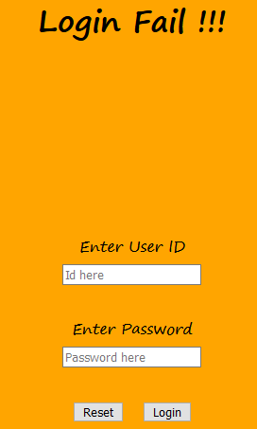

WelcomeServlet.java

/*

* To change this license header, choose License Headers in Project Properties.

* To change this template file, choose Tools | Templates

* and open the template in the editor.

*/

import java.io.IOException;

import java.io.PrintWriter;

import javax.servlet.ServletException;

import javax.servlet.http.HttpServlet;

import javax.servlet.http.HttpServletRequest;

import javax.servlet.http.HttpServletResponse;

/**

*

* @author H310MS2

*/

public class WelcomeServlet extends HttpServlet {

/**

* Processes requests for both HTTP <code>GET</code> and <code>POST</code>

* methods.

*

* @param request servlet request

* @param response servlet response

* @throws ServletException if a servlet-specific error occurs

* @throws IOException if an I/O error occurs

*/

protected void processRequest(HttpServletRequest request, HttpServletResponse response)

throws ServletException, IOException {

response.setContentType("text/html;charset=UTF-8");

try (PrintWriter out = response.getWriter()) {

/* TODO output your page here. You may use following sample code. */

out.println("<!DOCTYPE html>");

out.println("<html>");

out.println("<head>");

out.println("<title>Servlet WelcomeServlet</title>");

out.println("</head>");

out.println("<body>");

out.println("<body bgcolor=lightgreen>");

out.print("<br><br><br><br><br><br>");

out.println("<h1 align=center>Welcome "+request.getParameter("txtId") + "</h1>");

out.println("</body>");

out.println("</html>");

}

}

// <editor-fold defaultstate="collapsed" desc="HttpServlet methods. Click on the + sign on the left to edit the code.">

/**

* Handles the HTTP <code>GET</code> method.

*

* @param request servlet request

* @param response servlet response

* @throws ServletException if a servlet-specific error occurs

* @throws IOException if an I/O error occurs

*/

@Override

protected void doGet(HttpServletRequest request, HttpServletResponse response)

throws ServletException, IOException {

processRequest(request, response);

}

/**

* Handles the HTTP <code>POST</code> method.

*

* @param request servlet request

* @param response servlet response

* @throws ServletException if a servlet-specific error occurs

* @throws IOException if an I/O error occurs

*/

@Override

protected void doPost(HttpServletRequest request, HttpServletResponse response)

throws ServletException, IOException {

processRequest(request, response);

}

/**

* Returns a short description of the servlet.

*

* @return a String containing servlet description

*/

@Override

public String getServletInfo() {

return "Short description";

}// </editor-fold>

}



---------------------------------------------------------------------------------------------------------------------------

1. Create a servlet that uses Cookies to store the number of times a user has visited servlet.

Index.html

<!DOCTYPE html>

<!--

To change this license header, choose License Headers in Project Properties.

To change this template file, choose Tools | Templates

and open the template in the editor.

-->

<html>

<head>

<title>TODO supply a title</title>

<meta charset="UTF-8">

<meta name="viewport" content="width=device-width, initial-scale=1.0">

</head>

<body>

<form action="Page1" >

Enter Your Name <input type="text" name="txtName"><br><br>

<input type="submit" value="Click here to enter...">

</form>

</body>

</html>

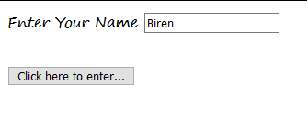

Page1.java

/*

* To change this license header, choose License Headers in Project Properties.

* To change this template file, choose Tools | Templates

* and open the template in the editor.

*/

import java.io.IOException;

import java.io.PrintWriter;

import javax.servlet.ServletException;

import javax.servlet.http.Cookie;

import javax.servlet.http.HttpServlet;

import javax.servlet.http.HttpServletRequest;

import javax.servlet.http.HttpServletResponse;

/**

*

* @author H310MS2

*/

public class Page1 extends HttpServlet {

/**

* Processes requests for both HTTP <code>GET</code> and <code>POST</code>

* methods.

*

* @param request servlet request

* @param response servlet response

* @throws ServletException if a servlet-specific error occurs

* @throws IOException if an I/O error occurs

*/

protected void processRequest(HttpServletRequest request, HttpServletResponse response)

throws ServletException, IOException {

response.setContentType("text/html;charset=UTF-8");

try (PrintWriter out = response.getWriter()) {

/* TODO output your page here. You may use following sample code. */

out.println("<!DOCTYPE html>");

out.println("<html>");

out.println("<head>");

out.println("<title>Servlet Page1</title>");

out.println("</head>");

out.println("<body bgcolor=pink>");

String username = request.getParameter("txtName");

out.println("<center><h1>Welcome "+username+"</h1></center>");

Cookie ck1 = new Cookie("Welcome", username);

Cookie ck2 = new Cookie("visit","1");

response.addCookie(ck1); response.addCookie(ck2);

out.println("<h3><a href=page2>Click to visit Page 2 </a></h3>");

out.println("</body>");

out.println("</html>");

}

}

// <editor-fold defaultstate="collapsed" desc="HttpServlet methods. Click on the + sign on the left to edit the code.">

/**

* Handles the HTTP <code>GET</code> method.

*

* @param request servlet request

* @param response servlet response

* @throws ServletException if a servlet-specific error occurs

* @throws IOException if an I/O error occurs

*/

@Override

protected void doGet(HttpServletRequest request, HttpServletResponse response)

throws ServletException, IOException {

processRequest(request, response);

}

/**

* Handles the HTTP <code>POST</code> method.

*

* @param request servlet request

* @param response servlet response

* @throws ServletException if a servlet-specific error occurs

* @throws IOException if an I/O error occurs

*/

@Override

protected void doPost(HttpServletRequest request, HttpServletResponse response)

throws ServletException, IOException {

processRequest(request, response);

}

/**

* Returns a short description of the servlet.

*

* @return a String containing servlet description

*/

@Override

public String getServletInfo() {

return "Short description";

}// </editor-fold>

}



Page2.java

/*

* To change this license header, choose License Headers in Project Properties.

* To change this template file, choose Tools | Templates

* and open the template in the editor.

*/

import java.io.IOException;

import java.io.PrintWriter;

import javax.servlet.ServletException;

import javax.servlet.http.Cookie;

import javax.servlet.http.HttpServlet;

import javax.servlet.http.HttpServletRequest;

import javax.servlet.http.HttpServletResponse;

/**

*

* @author H310MS2

*/

public class page2 extends HttpServlet {

/**

* Processes requests for both HTTP <code>GET</code> and <code>POST</code>

* methods.

*

* @param request servlet request

* @param response servlet response

* @throws ServletException if a servlet-specific error occurs

* @throws IOException if an I/O error occurs

*/

protected void processRequest(HttpServletRequest request, HttpServletResponse response)

throws ServletException, IOException {

response.setContentType("text/html;charset=UTF-8");

try (PrintWriter out = response.getWriter()) {

/* TODO output your page here. You may use following sample code. */

out.println("<!DOCTYPE html>");

out.println("<html>");

out.println("<head>");

out.println("<title>Servlet page2</title>");

out.println("</head>");

out.println("<body bgcolor= green>");

Cookie [] ck = request.getCookies();

for(int i=0;i<ck.length;i++)

{

if(ck[i].getName().equals("visit"))

{

int count = Integer.parseInt(ck[i].getValue())+1;

out.println("<h1>Visit No : "+count+"</h1>");

ck[i] = new Cookie("visit",count+ "");

response.addCookie(ck[i]);

}

else

out.println("Welcome "+ck[i].getValue());

}

out.println("<h3><a href=page3 >Click to visit Page 3 </a></h3>");

out.println("<h3><a href=page4 >Click to visit Page 4 </a></h3>");

out.println("<h3><a href=page5 >Click to visit Page 5 </a></h3>");

out.println("</body>");

out.println("</html>");

}

}

// <editor-fold defaultstate="collapsed" desc="HttpServlet methods. Click on the + sign on the left to edit the code.">

/**

* Handles the HTTP <code>GET</code> method.

*

* @param request servlet request

* @param response servlet response

* @throws ServletException if a servlet-specific error occurs

* @throws IOException if an I/O error occurs

*/

@Override

protected void doGet(HttpServletRequest request, HttpServletResponse response)

throws ServletException, IOException {

processRequest(request, response);

}

/**

* Handles the HTTP <code>POST</code> method.

*

* @param request servlet request

* @param response servlet response

* @throws ServletException if a servlet-specific error occurs

* @throws IOException if an I/O error occurs

*/

@Override

protected void doPost(HttpServletRequest request, HttpServletResponse response)

throws ServletException, IOException {

processRequest(request, response);

}

/**

* Returns a short description of the servlet.

*

* @return a String containing servlet description

*/

@Override

public String getServletInfo() {

return "Short description";

}// </editor-fold>

}

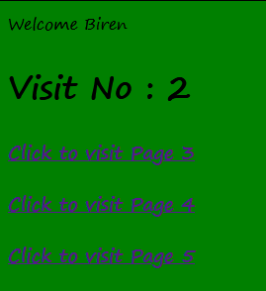

Page3.java

/*

* To change this license header, choose License Headers in Project Properties.

* To change this template file, choose Tools | Templates

* and open the template in the editor.

*/

import java.io.IOException;

import java.io.PrintWriter;

import javax.servlet.ServletException;

import javax.servlet.http.Cookie;

import javax.servlet.http.HttpServlet;

import javax.servlet.http.HttpServletRequest;

import javax.servlet.http.HttpServletResponse;

/**

*

* @author H310MS2

*/

public class page3 extends HttpServlet {

/**

* Processes requests for both HTTP <code>GET</code> and <code>POST</code>

* methods.

*

* @param request servlet request

* @param response servlet response

* @throws ServletException if a servlet-specific error occurs

* @throws IOException if an I/O error occurs

*/

protected void processRequest(HttpServletRequest request, HttpServletResponse response)

throws ServletException, IOException {

response.setContentType("text/html;charset=UTF-8");

try (PrintWriter out = response.getWriter()) {

/* TODO output your page here. You may use following sample code. */

out.println("<!DOCTYPE html>");

out.println("<html>");

out.println("<head>");

out.println("<title>Servlet page3</title>");

out.println("</head>");

out.println("<body bgcolor=yellow>");

Cookie [] ck = request.getCookies();

for(int i=0;i<ck.length;i++)

{

if(ck[i].getName().equals("visit"))

{

int count = Integer.parseInt(ck[i].getValue())+1;

out.println("<h1>Visit No : "+count+"</h1>");

ck[i] = new Cookie("visit",count+ "");

response.addCookie(ck[i]);

}

else

out.println(ck[i].getName()+ " "+ck[i].getValue());

}

out.println("<h3><a href=page2 >Click to visit Page 2 </a></h3>");

out.println("<h3><a href=page4 >Click to visit Page 4 </a></h3>");

out.println("<h3><a href=page5 >Click to visit Page 5 </a></h3>");

out.println("</body>");

out.println("</html>");

}

}

// <editor-fold defaultstate="collapsed" desc="HttpServlet methods. Click on the + sign on the left to edit the code.">

/**

* Handles the HTTP <code>GET</code> method.

*

* @param request servlet request

* @param response servlet response

* @throws ServletException if a servlet-specific error occurs

* @throws IOException if an I/O error occurs

*/

@Override

protected void doGet(HttpServletRequest request, HttpServletResponse response)

throws ServletException, IOException {

processRequest(request, response);

}

/**

* Handles the HTTP <code>POST</code> method.

*

* @param request servlet request

* @param response servlet response

* @throws ServletException if a servlet-specific error occurs

* @throws IOException if an I/O error occurs

*/

@Override

protected void doPost(HttpServletRequest request, HttpServletResponse response)

throws ServletException, IOException {

processRequest(request, response);

}

/**

* Returns a short description of the servlet.

*

* @return a String containing servlet description

*/

@Override

public String getServletInfo() {

return "Short description";

}// </editor-fold>

}

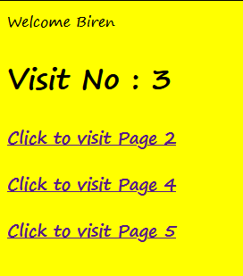

Page4.java

/*

* To change this license header, choose License Headers in Project Properties.

* To change this template file, choose Tools | Templates

* and open the template in the editor.

*/

import java.io.IOException;

import java.io.PrintWriter;

import javax.servlet.ServletException;

import javax.servlet.http.Cookie;

import javax.servlet.http.HttpServlet;

import javax.servlet.http.HttpServletRequest;

import javax.servlet.http.HttpServletResponse;

/**

*

* @author H310MS2

*/

public class page4 extends HttpServlet {

/**

* Processes requests for both HTTP <code>GET</code> and <code>POST</code>

* methods.

*

* @param request servlet request

* @param response servlet response

* @throws ServletException if a servlet-specific error occurs

* @throws IOException if an I/O error occurs

*/

protected void processRequest(HttpServletRequest request, HttpServletResponse response)

throws ServletException, IOException {

response.setContentType("text/html;charset=UTF-8");

try (PrintWriter out = response.getWriter()) {

/* TODO output your page here. You may use following sample code. */

out.println("<!DOCTYPE html>");

out.println("<html>");

out.println("<head>");

out.println("<title>Servlet page4</title>");

out.println("</head>");

out.println("<body bgcolor=cyan>");

Cookie [] ck = request.getCookies();

for(int i=0;i<ck.length;i++)

{

if(ck[i].getName().equals("visit"))

{

int count = Integer.parseInt(ck[i].getValue())+1;

out.println("<h1>Visit No : "+count+"</h1>");

ck[i] = new Cookie("visit",count+ "");

response.addCookie(ck[i]);

}

else

out.println("Welcome "+ck[i].getValue());

}

out.println("<h3><a href=page2 >Click to visit Page 2 </a></h3>");

out.println("<h3><a href=page3 >Click to visit Page 3 </a></h3>");

out.println("<h3><a href=page5 >Click to visit Page 5 </a></h3>");

out.println("</body>");

out.println("</html>");

}

}

// <editor-fold defaultstate="collapsed" desc="HttpServlet methods. Click on the + sign on the left to edit the code.">

/**

* Handles the HTTP <code>GET</code> method.

*

* @param request servlet request

* @param response servlet response

* @throws ServletException if a servlet-specific error occurs

* @throws IOException if an I/O error occurs

*/

@Override

protected void doGet(HttpServletRequest request, HttpServletResponse response)

throws ServletException, IOException {

processRequest(request, response);

}

/**

* Handles the HTTP <code>POST</code> method.

*

* @param request servlet request

* @param response servlet response

* @throws ServletException if a servlet-specific error occurs

* @throws IOException if an I/O error occurs

*/

@Override

protected void doPost(HttpServletRequest request, HttpServletResponse response)

throws ServletException, IOException {

processRequest(request, response);

}

/**

* Returns a short description of the servlet.

*

* @return a String containing servlet description

*/

@Override

public String getServletInfo() {

return "Short description";

}// </editor-fold>

}

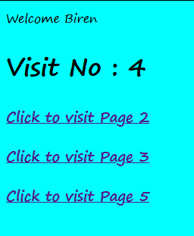

Page5.java

/*

* To change this license header, choose License Headers in Project Properties.

* To change this template file, choose Tools | Templates

* and open the template in the editor.

*/

import java.io.IOException;

import java.io.PrintWriter;

import javax.servlet.ServletException;

import javax.servlet.http.Cookie;

import javax.servlet.http.HttpServlet;

import javax.servlet.http.HttpServletRequest;

import javax.servlet.http.HttpServletResponse;

/**

*

* @author H310MS2

*/

public class page5 extends HttpServlet {

/**

* Processes requests for both HTTP <code>GET</code> and <code>POST</code>

* methods.

*

* @param request servlet request

* @param response servlet response

* @throws ServletException if a servlet-specific error occurs

* @throws IOException if an I/O error occurs

*/

protected void processRequest(HttpServletRequest request, HttpServletResponse response)

throws ServletException, IOException {

response.setContentType("text/html;charset=UTF-8");

try (PrintWriter out = response.getWriter()) {

/* TODO output your page here. You may use following sample code. */

out.println("<!DOCTYPE html>");

out.println("<html>");

out.println("<head>");

out.println("<title>Servlet page5</title>");

out.println("</head>");

out.println("<body bgcolor=red>");

Cookie [] ck = request.getCookies();

for(int i=0;i<ck.length;i++)

{

if(ck[i].getName().equals("visit"))

{

int count = Integer.parseInt(ck[i].getValue())+1;

out.println("<h1>Visit No : "+count+"</h1>");

ck[i] = new Cookie("visit",count+ "");

response.addCookie(ck[i]);

}

else

out.println("Welcome "+ck[i].getValue());

}

out.println("<h3><a href=page2 >Click to visit Page 2 </a></h3>");

out.println("<h3><a href=page3 >Click to visit Page 3 </a></h3>");

out.println("<h3><a href=page4 >Click to visit Page 4 </a></h3>");

out.println("</body>");

out.println("</html>");

}

}

// <editor-fold defaultstate="collapsed" desc="HttpServlet methods. Click on the + sign on the left to edit the code.">

/**

* Handles the HTTP <code>GET</code> method.

*

* @param request servlet request

* @param response servlet response

* @throws ServletException if a servlet-specific error occurs

* @throws IOException if an I/O error occurs

*/

@Override

protected void doGet(HttpServletRequest request, HttpServletResponse response)

throws ServletException, IOException {

processRequest(request, response);

}

/**

* Handles the HTTP <code>POST</code> method.

*

* @param request servlet request

* @param response servlet response

* @throws ServletException if a servlet-specific error occurs

* @throws IOException if an I/O error occurs

*/

@Override

protected void doPost(HttpServletRequest request, HttpServletResponse response)

throws ServletException, IOException {

processRequest(request, response);

}

/**

* Returns a short description of the servlet.

*

* @return a String containing servlet description

*/

@Override

public String getServletInfo() {

return "Short description";

}// </editor-fold>

}

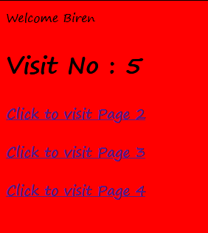

**---------------------------------------------------------------------------------------------------------------------------**

1. Create a servlet demonstrating the use of session creation and destruction. Also check whether the user has visited this page first time or has visited earlier also using sessions.

Index.html

<!DOCTYPE html>

<!--

To change this license header, choose License Headers in Project Properties.

To change this template file, choose Tools | Templates

and open the template in the editor.

-->

<html>

<head>

<title>Session Demo</title>

<meta charset="UTF-8">

<meta name="viewport" content="width=device-width, initial-scale=1.0">

</head>

<body>

<form action="Page1" method="get" >

Enter Your Name <input type="text" name="txtName"><br>

<input type="reset" >

<input type="submit" >

</form>

</body>

</html>

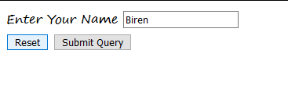

Page1.java

/*

* To change this license header, choose License Headers in Project Properties.

* To change this template file, choose Tools | Templates

* and open the template in the editor.

*/

import java.io.IOException;

import java.io.PrintWriter;

import javax.servlet.ServletException;

import javax.servlet.http.HttpServlet;

import javax.servlet.http.HttpServletRequest;

import javax.servlet.http.HttpServletResponse;

import javax.servlet.http.HttpSession;

/**

*

* @author H310MS2

*/

public class Page1 extends HttpServlet {

/**

* Processes requests for both HTTP <code>GET</code> and <code>POST</code>

* methods.

*

* @param request servlet request

* @param response servlet response

* @throws ServletException if a servlet-specific error occurs

* @throws IOException if an I/O error occurs

*/

protected void processRequest(HttpServletRequest request, HttpServletResponse response)

throws ServletException, IOException {

response.setContentType("text/html;charset=UTF-8");

try (PrintWriter out = response.getWriter()) {

/* TODO output your page here. You may use following sample code. */

out.println("<!DOCTYPE html>");

out.println("<html>");

out.println("<head>");

out.println("<title>Servlet Page1</title>");

HttpSession hs= request.getSession(true);

if(hs.isNew())

{

out.println("<body bgcolor=yellow>");

hs.setAttribute("visit", "1");

String username = request.getParameter("txtName");

hs.setAttribute("session_usrname", username);

out.println("<h1>Welcome First Time " + hs.getAttribute("session_usrname") + "</h1>");

}

else

{

out.println("<h1>Welcome Again, "+hs.getAttribute("session_usrname")+"</h1>");

int visit = Integer.parseInt((String)hs.getAttribute("visit"))+1;

out.println("<h1>You Visited "+visit+" Times</h1>");

hs.setAttribute("visit", ""+visit);

out.println("<h1>Your Session ID "+hs.getId()+"</h1>");

out.println("<h1>You Logged in at "+new java.util.Date(hs.getCreationTime())+"</h1>");

out.println("<h1><a href=Page2>Click for Page 2 </a></h1>");

out.println("<h1><a href=Page3>Click for Page 3 </a></h1>");

out.println("<h1><a href=Page4>Click for Page 4 </a></h1>");

out.println("<h1><a href=LogoutServlet>Click to Terminate Session </a></h1>");

}

out.println("</head>");

out.println("<body>");

out.println("</body>");

out.println("</html>");

}

}

// <editor-fold defaultstate="collapsed" desc="HttpServlet methods. Click on the + sign on the left to edit the code.">

/**

* Handles the HTTP <code>GET</code> method.

*

* @param request servlet request

* @param response servlet response

* @throws ServletException if a servlet-specific error occurs

* @throws IOException if an I/O error occurs

*/

@Override

protected void doGet(HttpServletRequest request, HttpServletResponse response)

throws ServletException, IOException {

processRequest(request, response);

}

/**

* Handles the HTTP <code>POST</code> method.

*

* @param request servlet request

* @param response servlet response

* @throws ServletException if a servlet-specific error occurs

* @throws IOException if an I/O error occurs

*/

@Override

protected void doPost(HttpServletRequest request, HttpServletResponse response)

throws ServletException, IOException {

processRequest(request, response);

}

/**

* Returns a short description of the servlet.

*

* @return a String containing servlet description

*/

@Override

public String getServletInfo() {

return "Short description";

}// </editor-fold>

}

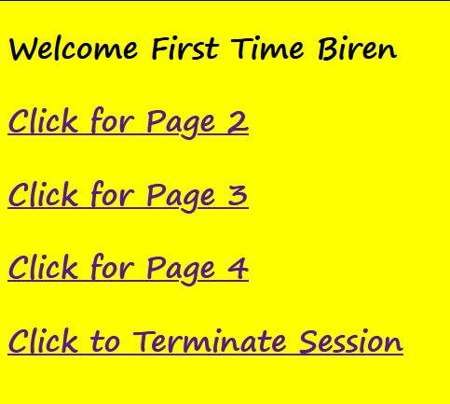

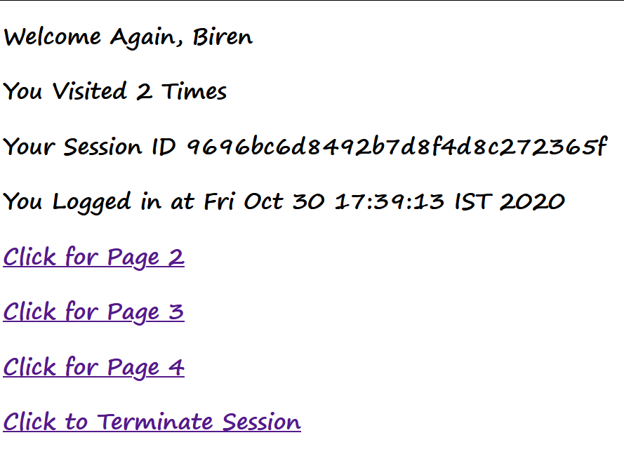

Page2.java

/*

* To change this license header, choose License Headers in Project Properties.

* To change this template file, choose Tools | Templates

* and open the template in the editor.

*/

import java.io.IOException;

import java.io.PrintWriter;

import javax.servlet.ServletException;

import javax.servlet.http.Cookie;

import javax.servlet.http.HttpServlet;

import javax.servlet.http.HttpServletRequest;

import javax.servlet.http.HttpServletResponse;

import javax.servlet.http.HttpSession;

/**

*

* @author H310MS2

*/

public class Page2 extends HttpServlet {

/**

* Processes requests for both HTTP <code>GET</code> and <code>POST</code>

* methods.

*

* @param request servlet request

* @param response servlet response

* @throws ServletException if a servlet-specific error occurs

* @throws IOException if an I/O error occurs

*/

protected void processRequest(HttpServletRequest request, HttpServletResponse response)

throws ServletException, IOException {

response.setContentType("text/html;charset=UTF-8");

try (PrintWriter out = response.getWriter()) {

/* TODO output your page here. You may use following sample code. */

out.println("<!DOCTYPE html>");

out.println("<html>");

out.println("<head>");

out.println("<title>Servlet Page2</title>");

out.println("</head>");

out.println("<body>");

HttpSession hs= request.getSession(false);

out.println("<h1>Welcome Again on Page No. 2 "+ hs.getAttribute("session_usrname") + "</h1>");

int visit = Integer.parseInt((String)hs.getAttribute("visit"))+1;

out.println("<h1>You Visited "+visit+" Times</h1>");

hs.setAttribute("visit", ""+visit);

out.println("<h1>Your Session ID "+hs.getId()+"</h1>");

out.println("<h1>You Logged in at "+new java.util.Date(hs.getCreationTime())+"</h1>");

out.println("<h1><a href=Page1>Click for Page 1 </a></h1>");

out.println("<h1><a href=Page3>Click for Page 3 </a></h1>");

out.println("<h1><a href=Page4>Click for Page 4 </a></h1>");

out.println("<h1><a href=LogoutServlet>Click for Terminate Session </a></h1>");

out.println("</body>");

out.println("</html>");

}

}

// <editor-fold defaultstate="collapsed" desc="HttpServlet methods. Click on the + sign on the left to edit the code.">

/**

* Handles the HTTP <code>GET</code> method.

*

* @param request servlet request

* @param response servlet response

* @throws ServletException if a servlet-specific error occurs

* @throws IOException if an I/O error occurs

*/

@Override

protected void doGet(HttpServletRequest request, HttpServletResponse response)

throws ServletException, IOException {

processRequest(request, response);

}

/**

* Handles the HTTP <code>POST</code> method.

*

* @param request servlet request

* @param response servlet response

* @throws ServletException if a servlet-specific error occurs

* @throws IOException if an I/O error occurs

*/

@Override

protected void doPost(HttpServletRequest request, HttpServletResponse response)

throws ServletException, IOException {

processRequest(request, response);

}

/**

* Returns a short description of the servlet.

*

* @return a String containing servlet description

*/

@Override

public String getServletInfo() {

return "Short description";

}// </editor-fold>

}

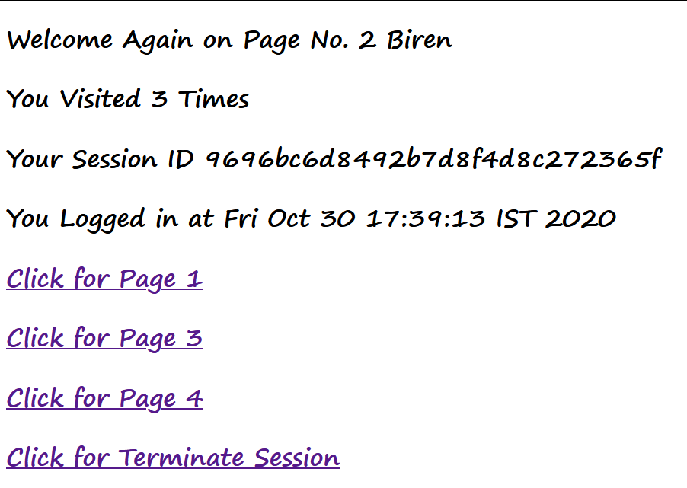

Page3.java

/*

* To change this license header, choose License Headers in Project Properties.

* To change this template file, choose Tools | Templates

* and open the template in the editor.

*/

import java.io.IOException;

import java.io.PrintWriter;

import javax.servlet.ServletException;

import javax.servlet.http.HttpServlet;

import javax.servlet.http.HttpServletRequest;

import javax.servlet.http.HttpServletResponse;

import javax.servlet.http.HttpSession;

/**

*

* @author H310MS2

*/

public class Page3 extends HttpServlet {

/**

* Processes requests for both HTTP <code>GET</code> and <code>POST</code>

* methods.

*

* @param request servlet request

* @param response servlet response

* @throws ServletException if a servlet-specific error occurs

* @throws IOException if an I/O error occurs

*/

protected void processRequest(HttpServletRequest request, HttpServletResponse response)

throws ServletException, IOException {

response.setContentType(“text/html;charset=UTF-8”);

try (PrintWriter out = response.getWriter()) {

/* TODO output your page here. You may use following sample code. */

out.println(“<!DOCTYPE html>”);

out.println(“<html>”);

out.println(“<head>”);

out.println(“<title>Servlet Page3</title>”);

out.println(“</head>”);

out.println(“<body>”);

HttpSession hs= request.getSession(false);

out.println(“<h1>Welcome Again on Page No. 3 “ + hs.getAttribute(“session_usrname”) + “</h1>”);

int visit = Integer.parseInt((String)hs.getAttribute(“visit”))+1;

out.println(“<h1>You Visited “+visit+” Times</h1>”);

hs.setAttribute(“visit “, “”+visit);

out.println(“<h1>Your Session ID “+hs.getId()+”</h1>”);

out.println(“<h1>You Logged in at “+new java.util.Date(hs.getCreationTime())+”</h1>”);

out.println(“<h1><a href=Page1>Click for Page 1 </a></h1>”);

out.println(“<h1><a href=Page2>Click for Page 2 </a></h1>”);

out.println(“<h1><a href=Page4>Click for Page 4 </a></h1>”);

out.println(“<h1><a href=LogoutServlet>Click for Terminate Session </a></h1>”);

out.println(“</body>”);

out.println(“</html>”);

}

}

// <editor-fold defaultstate=”collapsed” desc=”HttpServlet methods. Click on the + sign on the left to edit the code.”>

/**

* Handles the HTTP <code>GET</code> method.

*

* @param request servlet request

* @param response servlet response

* @throws ServletException if a servlet-specific error occurs

* @throws IOException if an I/O error occurs

*/

@Override

protected void doGet(HttpServletRequest request, HttpServletResponse response)

throws ServletException, IOException {

processRequest(request, response);

}

/**

* Handles the HTTP <code>POST</code> method.

*

* @param request servlet request

* @param response servlet response

* @throws ServletException if a servlet-specific error occurs

* @throws IOException if an I/O error occurs

*/

@Override

protected void doPost(HttpServletRequest request, HttpServletResponse response)

throws ServletException, IOException {

processRequest(request, response);

}

/**

* Returns a short description of the servlet.

*

* @return a String containing servlet description

*/

@Override

public String getServletInfo() {

return “Short description”;

}// </editor-fold>

}

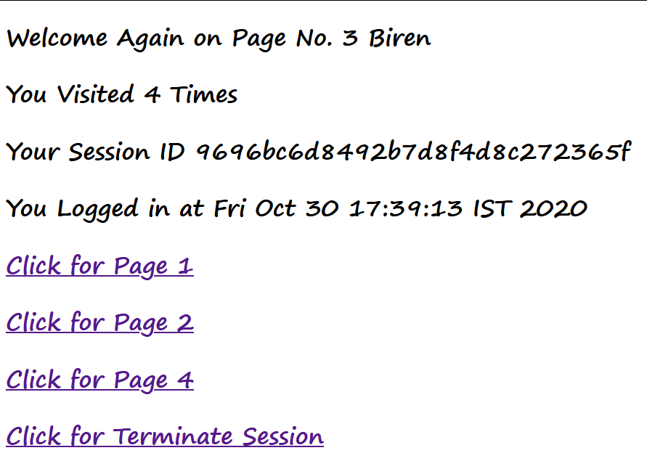

Page4.java

/*

* To change this license header, choose License Headers in Project Properties.

* To change this template file, choose Tools | Templates

* and open the template in the editor.

*/

import java.io.IOException;

import java.io.PrintWriter;

import javax.servlet.ServletException;

import javax.servlet.http.HttpServlet;

import javax.servlet.http.HttpServletRequest;

import javax.servlet.http.HttpServletResponse;

import javax.servlet.http.HttpSession;

/**

*

* @author H310MS2

*/

public class Page4 extends HttpServlet {

/**

* Processes requests for both HTTP <code>GET</code> and <code>POST</code>

* methods.

*

* @param request servlet request

* @param response servlet response

* @throws ServletException if a servlet-specific error occurs

* @throws IOException if an I/O error occurs

*/

protected void processRequest(HttpServletRequest request, HttpServletResponse response)

throws ServletException, IOException {

response.setContentType("text/html;charset=UTF-8");

try (PrintWriter out = response.getWriter()) {

/* TODO output your page here. You may use following sample code. */

out.println("<!DOCTYPE html>");

out.println("<html>");

out.println("<head>");

out.println("<title>Servlet Page4</title>");

out.println("</head>");

out.println("<body>");

HttpSession hs= request.getSession(false);

out.println("<h1>Welcome Again on Page No. 4 " + hs.getAttribute("session_usrname") + "</h1>");

int visit = Integer.parseInt((String)hs.getAttribute("visit"))+1;

out.println("<h1>You Visited "+visit+" Times</h1>");

hs.setAttribute("visit", ""+visit);

out.println("<h1>Your Session ID "+hs.getId()+"</h1>");

out.println("<h1>You Logged in at "+new java.util.Date(hs.getCreationTime())+"</h1>");

out.println("<h1><a href=Page1>Click for Page 1 </a></h1>");

out.println("<h1><a href=Page2>Click for Page 2 </a></h1>");

out.println("<h1><a href=Page3>Click for Page 3 </a></h1>");

out.println("<h1><a href=LogoutServlet>Click for Terminate Session </a></h1>");

out.println("</body>");

out.println("</html>");

}

}

// <editor-fold defaultstate="collapsed" desc="HttpServlet methods. Click on the + sign on the left to edit the code.">

/**

* Handles the HTTP <code>GET</code> method.

*

* @param request servlet request

* @param response servlet response

* @throws ServletException if a servlet-specific error occurs

* @throws IOException if an I/O error occurs

*/

@Override

protected void doGet(HttpServletRequest request, HttpServletResponse response)

throws ServletException, IOException {

processRequest(request, response);

}

/**

* Handles the HTTP <code>POST</code> method.

*

* @param request servlet request

* @param response servlet response

* @throws ServletException if a servlet-specific error occurs

* @throws IOException if an I/O error occurs

*/

@Override

protected void doPost(HttpServletRequest request, HttpServletResponse response)

throws ServletException, IOException {

processRequest(request, response);

}

/**

* Returns a short description of the servlet.

*

* @return a String containing servlet description

*/

@Override

public String getServletInfo() {

return "Short description";

}// </editor-fold>

}

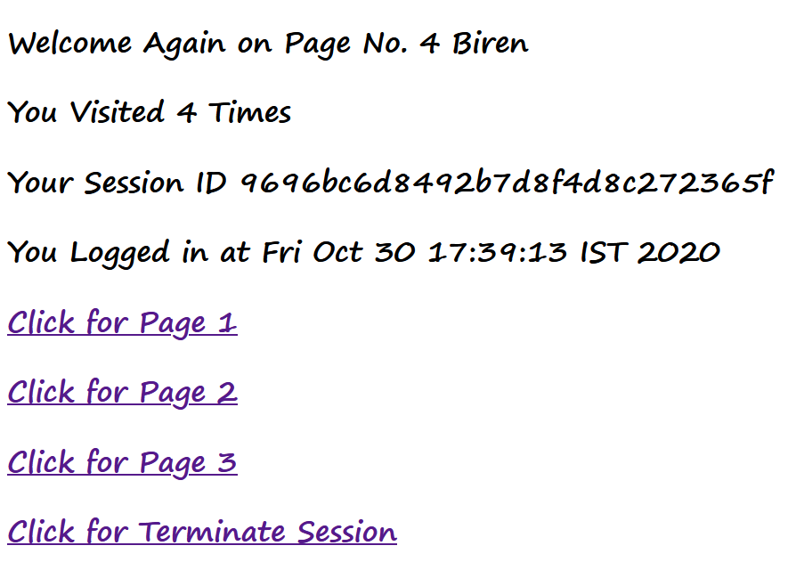

LogoutServlet.java

/*

* To change this license header, choose License Headers in Project Properties.

* To change this template file, choose Tools | Templates

* and open the template in the editor.

*/

import java.io.IOException;

import java.io.PrintWriter;

import javax.servlet.ServletException;

import javax.servlet.http.HttpServlet;

import javax.servlet.http.HttpServletRequest;

import javax.servlet.http.HttpServletResponse;

/**

*

* @author H310MS2

*/

public class LogoutServlet extends HttpServlet {

/**

* Processes requests for both HTTP <code>GET</code> and <code>POST</code>

* methods.

*

* @param request servlet request

* @param response servlet response

* @throws ServletException if a servlet-specific error occurs

* @throws IOException if an I/O error occurs

*/

protected void processRequest(HttpServletRequest request, HttpServletResponse response)

throws ServletException, IOException {

response.setContentType("text/html;charset=UTF-8");

try (PrintWriter out = response.getWriter()) {

/* TODO output your page here. You may use following sample code. */

out.println("<!DOCTYPE html>");

out.println("<html>");

out.println("<head>");

out.println("<title>Servlet LogoutServlet</title>");

out.println("</head>");

out.println("<body>");

javax.servlet.http.HttpSession hs = request.getSession();

if(hs!= null) hs.invalidate();

out.println("<h1>You are Logged out now........ </h1>");

out.println("</body>");

out.println("</html>");

}

}

// <editor-fold defaultstate="collapsed" desc="HttpServlet methods. Click on the + sign on the left to edit the code.">

/**

* Handles the HTTP <code>GET</code> method.

*

* @param request servlet request

* @param response servlet response

* @throws ServletException if a servlet-specific error occurs

* @throws IOException if an I/O error occurs

*/

@Override

protected void doGet(HttpServletRequest request, HttpServletResponse response)

throws ServletException, IOException {

processRequest(request, response);

}

/**

* Handles the HTTP <code>POST</code> method.

*

* @param request servlet request

* @param response servlet response

* @throws ServletException if a servlet-specific error occurs

* @throws IOException if an I/O error occurs

*/

@Override

protected void doPost(HttpServletRequest request, HttpServletResponse response)

throws ServletException, IOException {

processRequest(request, response);

}

/**

* Returns a short description of the servlet.

*

* @return a String containing servlet description

*/

@Override

public String getServletInfo() {

return "Short description";

}// </editor-fold>

}

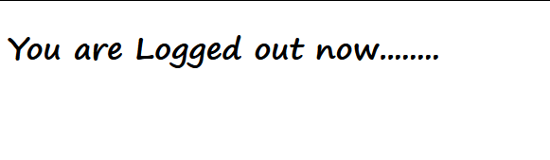

1. **Implement the Servlet IO and File applications.**
2. Create a Servlet application to upload and download a file.

Index.html

<!DOCTYPE html>

<!--

To change this license header, choose License Headers in Project Properties.

To change this template file, choose Tools | Templates

and open the template in the editor.

-->

<html>

<head>

<title>File Upload & Download</title>

<meta charset="UTF-8">

<meta name="viewport" content="width=device-width, initial-scale=1.0">

</head>

<body bgcolor="#FB8AC7">

<center>

<h1 >File Upload Application</h1><br>

<form action="FileUploadServlet" method="post" enctype="multipart/form-data">

Select File to Upload:<br>

<input type="file" name="file"><br>

Destination: <input type="text" name="destination"><br>

<input type="submit" value="Upload file" name="upload">

</form>

<HR> <HR><HR><HR>

<h1>File Download Application</h1>

Click <a href="FileDownloadServlet?filename=4.129 TYBSC IT.pdf">TY BSc-IT Syllabus</a><br/><br/>

Click<a href="FileDownloadServlet?filename=TYBSC-IT_SEM5_EJ_NOV18.pdf">University Exam Question Paper Nov 2018</a>

</center>

</body>

</html>

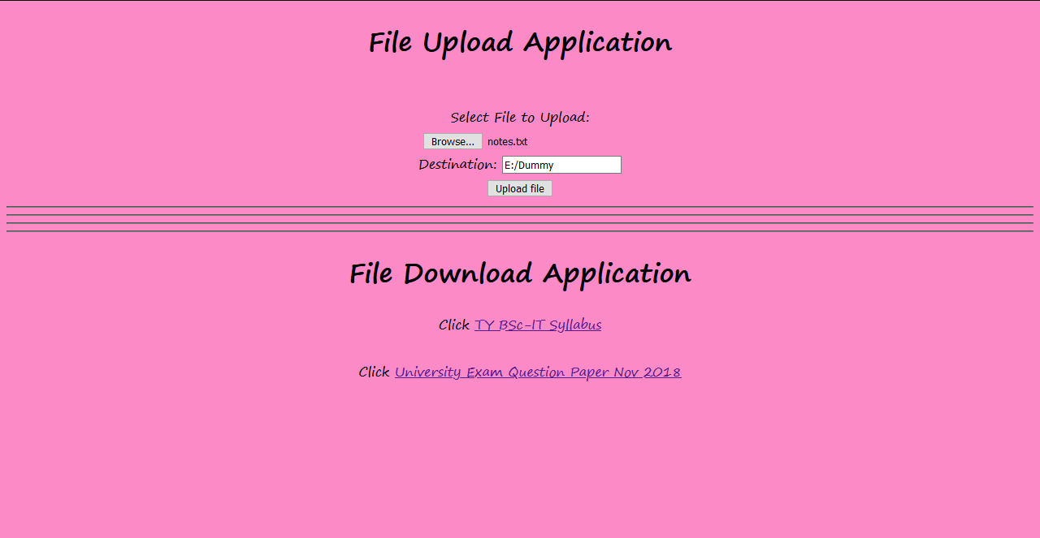

FileUploadServlet.java

/*

* To change this license header, choose License Headers in Project Properties.

* To change this template file, choose Tools | Templates

* and open the template in the editor.

*/

import java.io.File;

import java.io.FileOutputStream;

import java.io.IOException;

import java.io.PrintWriter;

import javax.servlet.ServletException;

import javax.servlet.annotation.MultipartConfig;

import javax.servlet.http.HttpServlet;

import javax.servlet.http.HttpServletRequest;

import javax.servlet.http.HttpServletResponse;

import java.io.FileNotFoundException;

import java.io.InputStream;

import java.io.OutputStream;

import javax.servlet.http.Part;

/**

*

* @author H310MS2

*/

@MultipartConfig

public class FileUploadServlet extends HttpServlet {

/**

* Processes requests for both HTTP <code>GET</code> and <code>POST</code>

* methods.

*

* @param request servlet request

* @param response servlet response

* @throws ServletException if a servlet-specific error occurs

* @throws IOException if an I/O error occurs

*/

protected void processRequest(HttpServletRequest request, HttpServletResponse response)

throws ServletException, IOException {

response.setContentType("text/html;charset=UTF-8");

try (PrintWriter out = response.getWriter()) {

/* TODO output your page here. You may use following sample code. */

out.println("<!DOCTYPE html>");

out.println("<html>");

out.println("<head>");

out.println("<title>Servlet FileUploadServlet</title>");

out.println("</head>");

out.println("<body bgcolor=#B9FF6E >");

String path=request.getParameter("destination");

Part filePart=request.getPart("file");

String filename=filePart.getSubmittedFileName();

out.print("<br><br><hr> file name: "+filename);

OutputStream os = null;

InputStream is=null;

try {

os=new FileOutputStream(new File(path+File.separator+filename));

is=filePart.getInputStream();

int read=0;

while ((read = is.read()) != -1)

{

os.write(read);

}

out.println("<br>file uploaded sucessfully...!!!");

}

catch

(FileNotFoundException e)

{

out.print(e);

}

out.println("</body>");

out.println("</html>");

}

}

// <editor-fold defaultstate="collapsed" desc="HttpServlet methods. Click on the + sign on the left to edit the code.">

/**

* Handles the HTTP <code>GET</code> method.

*

* @param request servlet request

* @param response servlet response

* @throws ServletException if a servlet-specific error occurs

* @throws IOException if an I/O error occurs

*/

@Override

protected void doGet(HttpServletRequest request, HttpServletResponse response)

throws ServletException, IOException {

processRequest(request, response);

}

/**

* Handles the HTTP <code>POST</code> method.

*

* @param request servlet request

* @param response servlet response

* @throws ServletException if a servlet-specific error occurs

* @throws IOException if an I/O error occurs

*/

@Override

protected void doPost(HttpServletRequest request, HttpServletResponse response)

throws ServletException, IOException {

processRequest(request, response);

}

/**

* Returns a short description of the servlet.

*

* @return a String containing servlet description

*/

@Override

public String getServletInfo() {

return "Short description";

}// </editor-fold>

}

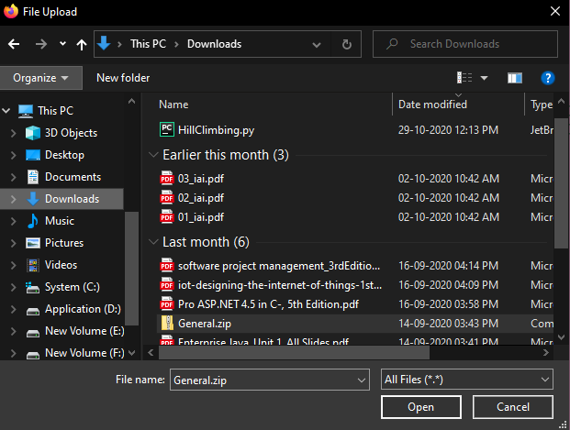

FileDownloadServlet.java

/*

* To change this license header, choose License Headers in Project Properties.

* To change this template file, choose Tools | Templates

* and open the template in the editor.

*/

import java.io.IOException;

import java.io.PrintWriter;

import java.io.InputStream;

import javax.servlet.ServletContext;

import javax.servlet.ServletException;

import javax.servlet.http.HttpServlet;

import javax.servlet.http.HttpServletRequest;

import javax.servlet.http.HttpServletResponse;

/**

*

* @author H310MS2

*/

public class FileDownloadServlet extends HttpServlet {

/**

* Processes requests for both HTTP <code>GET</code> and <code>POST</code>

* methods.

*

* @param request servlet request

* @param response servlet response

* @throws ServletException if a servlet-specific error occurs

* @throws IOException if an I/O error occurs

*/

protected void processRequest(HttpServletRequest request, HttpServletResponse response)

throws ServletException, IOException {

response.setContentType("text/html;charset=UTF-8");

try (PrintWriter out = response.getWriter()) {

/* TODO output your page here. You may use following sample code. */

out.println("<!DOCTYPE html>");

out.println("<html>");

out.println("<head>");

out.println("<title>Servlet FileDownloadServlet</title>");

out.println("</head>");

out.println("<body>");

response.setContentType("APPLICATION/OCTET-STREAM");

String filename = request.getParameter("filename");

ServletContext context = getServletContext();

try (

InputStream is = context.getResourceAsStream("/" + filename)) {

response.setHeader("Content-Disposition","attachment; filename=\"" + filename + "\"");

int i;

while ((i=is.read()) != -1)

{

out.write(i)

;

}

}

out.close();

out.println("</body>");

out.println("</html>");

}

}

// <editor-fold defaultstate="collapsed" desc="HttpServlet methods. Click on the + sign on the left to edit the code.">

/**

* Handles the HTTP <code>GET</code> method.

*

* @param request servlet request

* @param response servlet response

* @throws ServletException if a servlet-specific error occurs

* @throws IOException if an I/O error occurs

*/

@Override

protected void doGet(HttpServletRequest request, HttpServletResponse response)

throws ServletException, IOException {

processRequest(request, response);

}

/**

* Handles the HTTP <code>POST</code> method.

*

* @param request servlet request

* @param response servlet response

* @throws ServletException if a servlet-specific error occurs

* @throws IOException if an I/O error occurs

*/

@Override

protected void doPost(HttpServletRequest request, HttpServletResponse response)

throws ServletException, IOException {

processRequest(request, response);

}

/**

* Returns a short description of the servlet.

*

* @return a String containing servlet description

*/

@Override

public String getServletInfo() {

return "Short description";

}// </editor-fold>

}

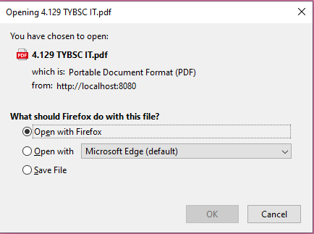

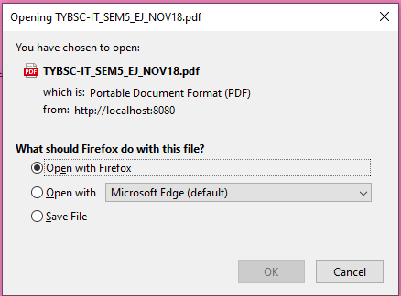

**---------------------------------------------------------------------------------------------------------------------------**

1. Develop Simple Servlet Question Answer Application using Database.

Index.html

<!DOCTYPE html>

<!--

To change this license header, choose License Headers in Project Properties.

To change this template file, choose Tools | Templates

and open the template in the editor.

-->

<html>

<head>

<title> Quiz </title>

<meta charset="UTF-8">

<meta name="viewport" content="width=device-width, initial-scale=1.0">

</head>

<body>

<div align=center>

<h1>Welcome to Quiz Servlet </h1>

<h1>

<a href="QuizServlet">CLICK TO START QUIZ</a>

</h1>

</div>

</body>

</html>

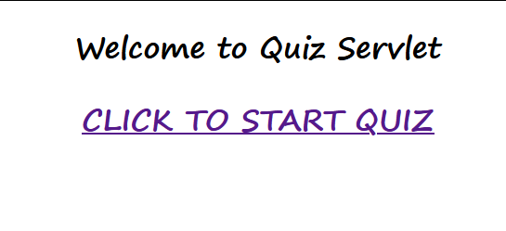

QuizServlet.java

/*

* To change this license header, choose License Headers in Project Properties.

* To change this template file, choose Tools | Templates

* and open the template in the editor.

*/

import java.io.IOException;

import java.io.PrintWriter;

import java.sql.Connection;

import java.sql.DriverManager;

import java.sql.ResultSet;

import java.sql.Statement;

import javax.servlet.ServletException;

import javax.servlet.http.HttpServlet;

import javax.servlet.http.HttpServletRequest;

import javax.servlet.http.HttpServletResponse;

/**

*

* @author H310MS2

*/

public class QuizServlet extends HttpServlet {

/**

* Processes requests for both HTTP <code>GET</code> and <code>POST</code>

* methods.

*

* @param request servlet request

* @param response servlet response

* @throws ServletException if a servlet-specific error occurs

* @throws IOException if an I/O error occurs

*/

protected void processRequest(HttpServletRequest request, HttpServletResponse response)

throws ServletException, IOException {

response.setContentType("text/html;charset=UTF-8");

try (PrintWriter out = response.getWriter())

{

/* TODO output your page here. You may use following sample code. */

out.println("<!DOCTYPE html>");

out.println("<html>");

out.println("<head>");

out.println("<title>Servlet QuizServlet</title>");

out.println("</head>");

out.println("<body>");

out.println("<form action=ShowResult>");

try {

Class.forName("com.mysql.jdbc.Driver");

Connection con = DriverManager.getConnection("jdbc:mysql://localhost:3306/test","root","root");

Statement stmt = con.createStatement();

ResultSet res = stmt.executeQuery("select * from quiz");

out.println("<table border=1 align=center>");

int qno=0;

while(res.next())

{

qno++;out.println("<tr><td>"+res.getString(1)+"</td>");

out.println("<td>"+res.getString(2)+"</td></tr>");

out.println("<tr><td><input type=radio name="+(qno)+" value="+res.getString(3)+"></td><td>"+res.getString(3)+"</td></tr>");

out.println("<tr><td><input type=radio name="+(qno)+" value="+res.getString(4)+"></td><td>"+res.getString(4)+"</td></tr>");

out.println("<tr><td><input type=radio name="+(qno)+" value="+res.getString(5)+"></td><td>"+res.getString(5)+"</td></tr>");

out.println("<tr><td><input type=radio name="+(qno)+" value="+res.getString(6)+"></td><td>"+res.getString(6)+"</td></tr>");

}

}

catch(Exception e)

{

out.println(e);

}

out.println("</table>");

out.println("<input type=reset>");

out.println("<input type=submit value=SUBMIT>");

out.println("</form>");

out.println("</body>");

out.println("</html>");

}

}

// <editor-fold defaultstate="collapsed" desc="HttpServlet methods. Click on the + sign on the left to edit the code.">

/**

* Handles the HTTP <code>GET</code> method.

*

* @param request servlet request

* @param response servlet response

* @throws ServletException if a servlet-specific error occurs

* @throws IOException if an I/O error occurs

*/

@Override

protected void doGet(HttpServletRequest request, HttpServletResponse response)

throws ServletException, IOException {

processRequest(request, response);

}

/**

* Handles the HTTP <code>POST</code> method.

*

* @param request servlet request

* @param response servlet response

* @throws ServletException if a servlet-specific error occurs

* @throws IOException if an I/O error occurs

*/

@Override

protected void doPost(HttpServletRequest request, HttpServletResponse response)

throws ServletException, IOException {

processRequest(request, response);

}

/**

* Returns a short description of the servlet.

*

* @return a String containing servlet description

*/

@Override

public String getServletInfo() {

return "Short description";

}// </editor-fold>

}

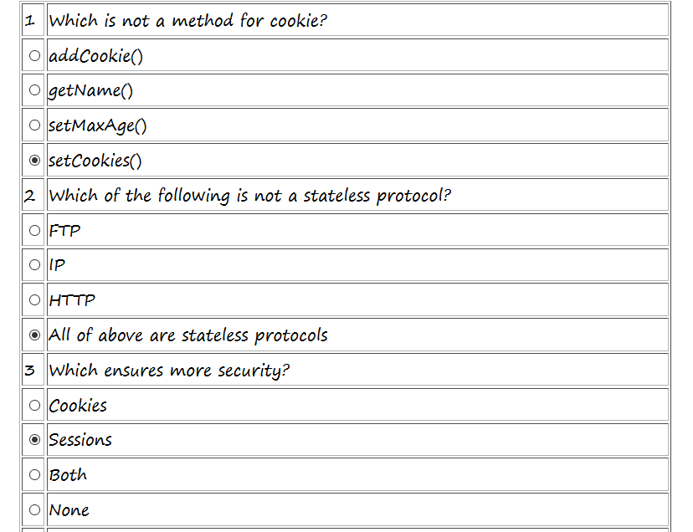

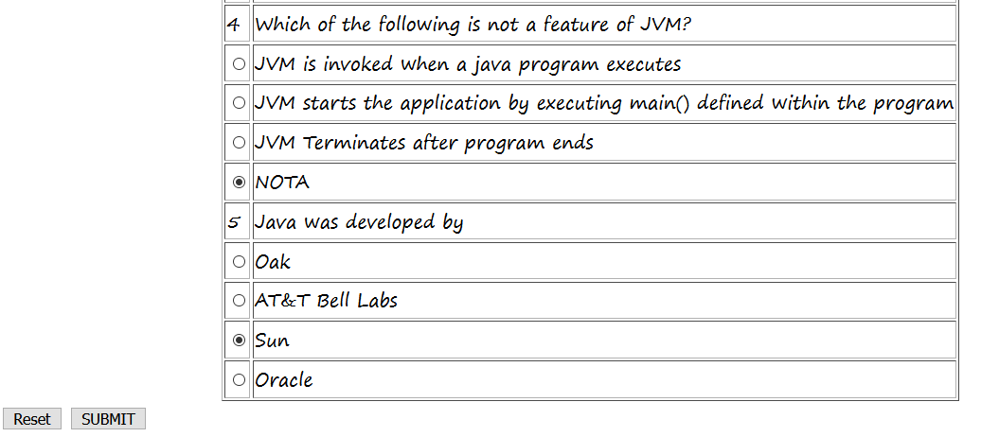

ShowResult.java

/*

* To change this license header, choose License Headers in Project Properties.

* To change this template file, choose Tools | Templates

* and open the template in the editor.

*/

import java.io.IOException;

import java.io.PrintWriter;

import java.sql.Connection;

import java.sql.DriverManager;

import java.sql.ResultSet;

import java.sql.Statement;

import javax.servlet.ServletException;

import javax.servlet.http.HttpServlet;

import javax.servlet.http.HttpServletRequest;

import javax.servlet.http.HttpServletResponse;

/**

*

* @author H310MS2

*/

public class ShowResult extends HttpServlet {

/**

* Processes requests for both HTTP <code>GET</code> and <code>POST</code>

* methods.

*

* @param request servlet request

* @param response servlet response

* @throws ServletException if a servlet-specific error occurs

* @throws IOException if an I/O error occurs

*/

protected void processRequest(HttpServletRequest request, HttpServletResponse response)

throws ServletException, IOException {

response.setContentType("text/html;charset=UTF-8");

try (PrintWriter out = response.getWriter()) {

/* TODO output your page here. You may use following sample code. */

out.println("<!DOCTYPE html>");

out.println("<html>");

out.println("<head>");

out.println("<title>Servlet ShowResult</title>");

out.println("</head>");

out.println("<body>");

try

{

Class.forName("com.mysql.jdbc.Driver");

Connection con = DriverManager.getConnection("jdbc:mysql://localhost:3306/test","root","root");

Statement stmt = con.createStatement();

ResultSet res = stmt.executeQuery("select answer from quiz");

int count =0, qno=0;

while(res.next())

{

if(res.getString(1).equalsIgnoreCase(request.getParameter(""+(++qno))))

{

count++;

out.println("<h1 align=center style=\"color:green\"> " + qno+ " is Correct </h1>");

}

else{

out.println("<h1 align=center style=\"color:red\"> " + qno+ " is Incorrect</h1>");

}

}

out.println("<h1 align=center>Your Score is "+count+" </h1>");

}

catch(Exception e)

{

out.println(e);

}

out.println("</body>");

out.println("</html>");

}

}

// <editor-fold defaultstate="collapsed" desc="HttpServlet methods. Click on the + sign on the left to edit the code.">

/**

* Handles the HTTP <code>GET</code> method.

*

* @param request servlet request

* @param response servlet response

* @throws ServletException if a servlet-specific error occurs

* @throws IOException if an I/O error occurs

*/

@Override

protected void doGet(HttpServletRequest request, HttpServletResponse response)

throws ServletException, IOException {

processRequest(request, response);

}

/**

* Handles the HTTP <code>POST</code> method.

*

* @param request servlet request

* @param response servlet response

* @throws ServletException if a servlet-specific error occurs

* @throws IOException if an I/O error occurs

*/

@Override

protected void doPost(HttpServletRequest request, HttpServletResponse response)

throws ServletException, IOException {

processRequest(request, response);

}

/**

* Returns a short description of the servlet.

*

* @return a String containing servlet description

*/

@Override

public String getServletInfo() {

return "Short description";

}// </editor-fold>

}

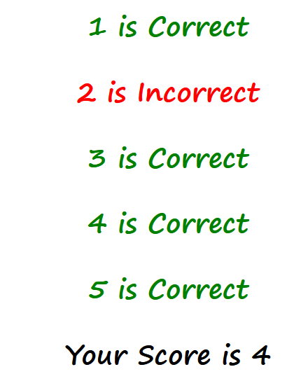

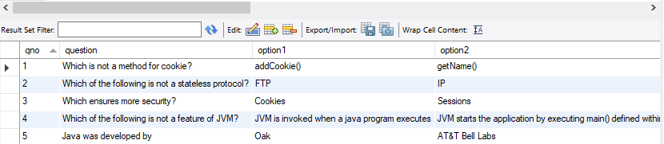

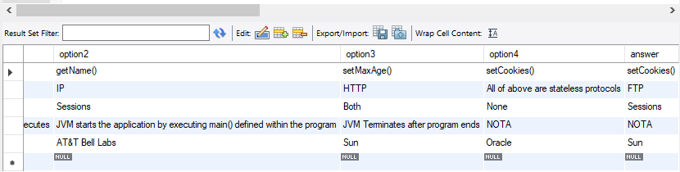

**---------------------------------------------------------------------------------------------------------------------------**

1. Create simple Servlet application to demonstrate Non-Blocking Read Operation.

Index.html

<!DOCTYPE html>

<!--

To change this license header, choose License Headers in Project Properties.

To change this template file, choose Tools | Templates

and open the template in the editor.

-->

<html>

<head>

<meta http-equiv="Refresh" content="1; URL=NonBlockingServlet">

<title>Non-blocking I/O</title>

</head>

<body>

</body>

</html>

ReadingListener.java

/*

* To change this license header, choose License Headers in Project Properties.

* To change this template file, choose Tools | Templates

* and open the template in the editor.

*/

/**

*

* @author H310MS2

*/

import java.io.IOException;

import javax.servlet.AsyncContext;

import javax.servlet.ReadListener;

import javax.servlet.ServletInputStream;

public class ReadingListener implements ReadListener{

private ServletInputStream input = null;

private AsyncContext ac = null;

ReadingListener(ServletInputStream in, AsyncContext c) {input = in; ac = c;}

@Override public void onDataAvailable() throws IOException{

}

@Override public void onAllDataRead() throws IOException

{

ac.complete();

}

@Override public void onError(final Throwable t)

{

ac.complete();

t.printStackTrace();

}

}

ReadingListener.java

/*

* To change this license header, choose License Headers in Project Properties.

* To change this template file, choose Tools | Templates

* and open the template in the editor.

*/

/**

*

* @author H310MS2

*/

import java.io.IOException;

import javax.servlet.AsyncContext;

import javax.servlet.ReadListener;

import javax.servlet.ServletInputStream;

public class ReadingListener implements ReadListener{

private ServletInputStream input = null;

private AsyncContext ac = null;

ReadingListener(ServletInputStream in, AsyncContext c) {input = in; ac = c;}

@Override public void onDataAvailable() throws IOException{

}

@Override public void onAllDataRead() throws IOException

{

ac.complete();

}

@Override public void onError(final Throwable t)

{

ac.complete();

t.printStackTrace();

}

}

NonBlockingServlet.java

/*

* To change this license header, choose License Headers in Project Properties.

* To change this template file, choose Tools | Templates

* and open the template in the editor.

*/

import java.io.BufferedReader;

import java.io.BufferedWriter;

import java.io.IOException;

import java.io.InputStream;

import java.io.InputStreamReader;

import java.io.OutputStreamWriter;

import java.io.PrintWriter;

import java.net.HttpURLConnection;

import java.net.URL;

import javax.servlet.ServletContext;

import javax.servlet.ServletException;

import javax.servlet.http.HttpServlet;

import javax.servlet.http.HttpServletRequest;

import javax.servlet.http.HttpServletResponse;

/**

*

* @author H310MS2

*/

public class NonBlockingServlet extends HttpServlet {

/**

* Processes requests for both HTTP <code>GET</code> and <code>POST</code>

* methods.

*

* @param request servlet request

* @param response servlet response

* @throws ServletException if a servlet-specific error occurs

* @throws IOException if an I/O error occurs

*/

protected void processRequest(HttpServletRequest request, HttpServletResponse response)

throws ServletException, IOException {

response.setContentType("text/html;charset=UTF-8");

try (PrintWriter out = response.getWriter()) {

/* TODO output your page here. You may use following sample code. */

out.println("<!DOCTYPE html>");

out.println("<html>");

out.println("<head>");

out.println("<title>Servlet NonBlockingServlet</title>");

out.println("</head>");

out.println("<body>");

out.println("<h1>FileReader</h1>");

String filename="/WEB-INF/booklist.txt";

ServletContext c = getServletContext();

InputStream in=c.getResourceAsStream(filename);

String path = "http://"+request.getServerName()+":"

+request.getServerPort()+request.getContextPath()+

"/ReadingNonBlockingServlet";

URL url=new URL(path);

HttpURLConnection conn=(HttpURLConnection)url.openConnection();

conn.setChunkedStreamingMode(2);

conn.setDoOutput(true);

conn.connect();

if(in!=null)

{

InputStreamReader inr = new InputStreamReader(in);

BufferedReader br= new BufferedReader(inr);

String text="";

out.println("Reading started....");

BufferedWriter bw = new BufferedWriter(new OutputStreamWriter(conn.getOutputStream()));

while((text=br.readLine())!=null)

{

out.print("<br>"+text);

try

{

Thread.sleep(1000);

out.flush();

}

catch(InterruptedException ex){}

}

out.println("reading completed....");

bw.flush();

bw.close();

}

out.println("</body>");

out.println("</html>");

}

}

// <editor-fold defaultstate="collapsed" desc="HttpServlet methods. Click on the + sign on the left to edit the code.">

/**

* Handles the HTTP <code>GET</code> method.

*

* @param request servlet request

* @param response servlet response

* @throws ServletException if a servlet-specific error occurs

* @throws IOException if an I/O error occurs

*/

@Override

protected void doGet(HttpServletRequest request, HttpServletResponse response)

throws ServletException, IOException {

processRequest(request, response);

}

/**

* Handles the HTTP <code>POST</code> method.

*

* @param request servlet request

* @param response servlet response

* @throws ServletException if a servlet-specific error occurs

* @throws IOException if an I/O error occurs

*/

@Override

protected void doPost(HttpServletRequest request, HttpServletResponse response)

throws ServletException, IOException {

processRequest(request, response);

}

/**

* Returns a short description of the servlet.

*

* @return a String containing servlet description

*/

@Override

public String getServletInfo() {

return "Short description";

}// </editor-fold>

}

ReadingNonBlockingServlet.java

/*

* To change this license header, choose License Headers in Project Properties.

* To change this template file, choose Tools | Templates

* and open the template in the editor.

*/

import java.io.IOException;

import java.io.PrintWriter;

import javax.servlet.AsyncContext;

import javax.servlet.ServletException;

import javax.servlet.ServletInputStream;

import javax.servlet.http.HttpServlet;

import javax.servlet.http.HttpServletRequest;

import javax.servlet.http.HttpServletResponse;

/**

*

* @author H310MS2

*/

public class ReadingNonBlockingServlet extends HttpServlet {

/**

* Processes requests for both HTTP <code>GET</code> and <code>POST</code>

* methods.

*

* @param request servlet request

* @param response servlet response

* @throws ServletException if a servlet-specific error occurs

* @throws IOException if an I/O error occurs

*/

protected void processRequest(HttpServletRequest request, HttpServletResponse response)

throws ServletException, IOException {

response.setContentType("text/html;charset=UTF-8");

try (PrintWriter out = response.getWriter()) {

/* TODO output your page here. You may use following sample code. */

out.println("<!DOCTYPE html>");

out.println("<html>");

out.println("<head>");

out.println("<title>Servlet ReadingNonBlockingServlet</title>");

out.println("</head>");

out.println("<body>");

response.setContentType("text/html");

AsyncContext ac = request.startAsync();

ServletInputStream in = request.getInputStream();

in.setReadListener(new ReadingListener(in,ac));

out.println("</body>");

out.println("</html>");

}

}

// <editor-fold defaultstate="collapsed" desc="HttpServlet methods. Click on the + sign on the left to edit the code.">

/**

* Handles the HTTP <code>GET</code> method.

*

* @param request servlet request

* @param response servlet response

* @throws ServletException if a servlet-specific error occurs

* @throws IOException if an I/O error occurs

*/

@Override

protected void doGet(HttpServletRequest request, HttpServletResponse response)

throws ServletException, IOException {

processRequest(request, response);

}

/**

* Handles the HTTP <code>POST</code> method.

*

* @param request servlet request

* @param response servlet response

* @throws ServletException if a servlet-specific error occurs

* @throws IOException if an I/O error occurs

*/

@Override

protected void doPost(HttpServletRequest request, HttpServletResponse response)

throws ServletException, IOException {

processRequest(request, response);

}

/**

* Returns a short description of the servlet.

*

* @return a String containing servlet description

*/

@Override

public String getServletInfo() {

return "Short description";

}// </editor-fold>

}

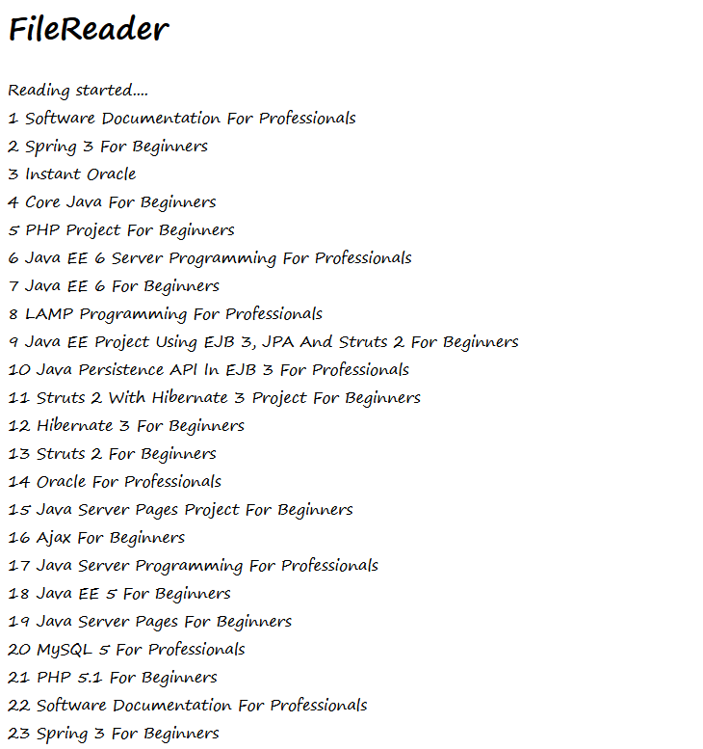

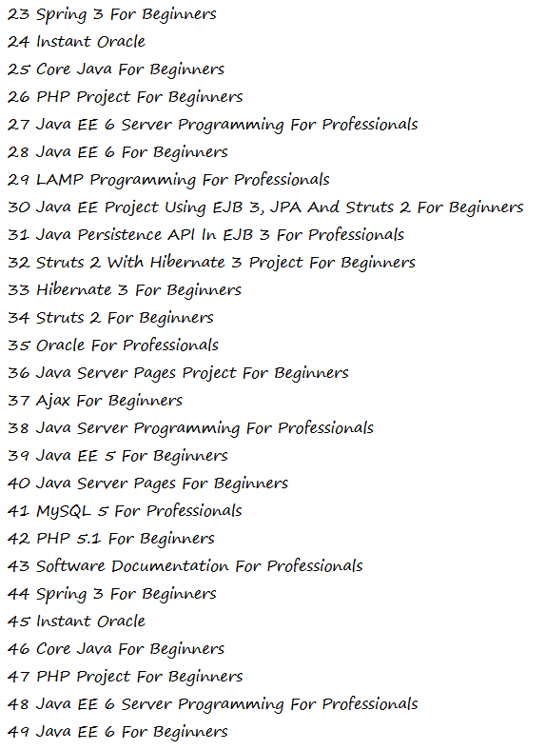

1. **Implement the following JSP applications.**
2. Develop a simple JSP application to display values obtained from the use of intrinsic objects of various types.

Index.html

<!DOCTYPE html>

<!--

To change this license header, choose License Headers in Project Properties.

To change this template file, choose Tools | Templates

and open the template in the editor.

-->

<html>

<head>

<title>Implicit Objects </title>

<meta charset="UTF-8">

<meta name="viewport" content="width=device-width, initial-scale=1.0">

</head>

<body>

<br><br><br><br><br>

<form action="index.jsp">

<div align="center" style="background-color:powderblue; margin-left:35%;margin-right: 35%; padding-top: 20px; padding-bottom:20px; " >

Enter your first name<br>

<input type="text" name="fname"><br><br>

Enter your last name<br>

<input type="text" name="lname"><br>

<input type="submit" value="Save">

</div>

</form>

</body>

</html>

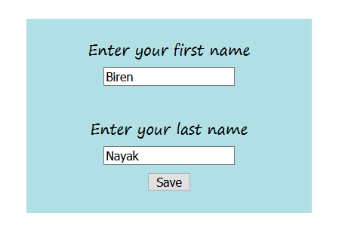

Index.jsp

<%--

Document : index

Created on : 19 Oct, 2020, 3:38:26 PM

Author : H310MS2

--%>

<%@page contentType="text/html" pageEncoding="UTF-8"%>

<!DOCTYPE html>

<html>

<head>

<meta http-equiv="Content-Type" content="text/html; charset=UTF-8">

<title>Intrinsic Objects</title>

</head>

<body>

<div style="background-color:powderblue; margin-left:5%;margin-right: 5%; padding: 10px; " >

<h1 align=center">Use of Intrinsic Objects in JSP </h1>

<div style="align-self: center;">Request Object</div>

Query String <%=request.getQueryString() %><br>

Context Path <%=request.getContextPath() %><br>

Remote Host <%=request.getRemoteHost() %><br>

<div style="align-items: center;">Response Object </div>

Character Encoding Type <%=response.getCharacterEncoding() %><br>

Content Type <%=response.getContentType() %><br>

Locale <%=response.getLocale() %><br>

<div style="align-content: center;">Session Object </div> ID <%=session.getId() %><br>

Creation Time <%=new java.util.Date(session.getCreationTime()) %><br>

Last Access Time<%=new java.util.Date(session.getLastAccessedTime()) %><br>

</div>

</body>

</html>

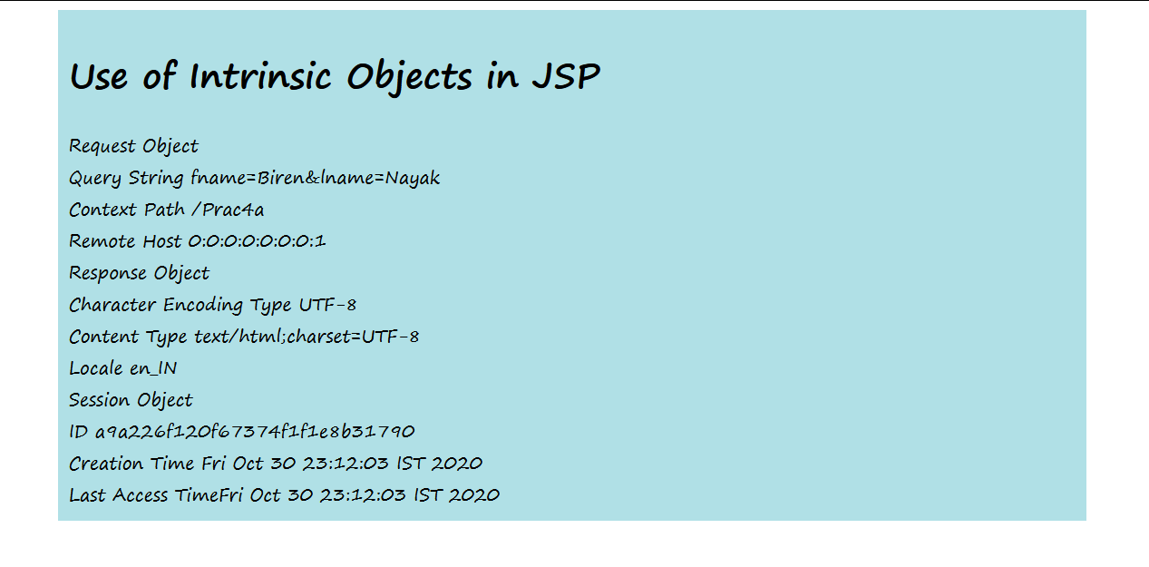

---------------------------------------------------------------------------------------------------------------------

1. Develop a simple JSP application to pass values from one page to another with validations. (Name-txt, age-txt, hobbies-checkbox, email-txt, gender-radio button).

Index.html

<!DOCTYPE html>

<!--

To change this license header, choose License Headers in Project Properties.

To change this template file, choose Tools | Templates

and open the template in the editor.

-->

<html>

<head>

<title>User Information Page</title>

</head>

<body>

<form action="Validate.jspx">

Enter Your Name: <input type="text" name="name" ><br>

Enter Your Age: <input type="text" name="age" ><br>

Select Hobbies:

<input type="checkbox" name="hob" value="Singing">Singing

<input type="checkbox" name="hob" value="Reading"> Reading Books

<input type="checkbox" name="hob" value="Football"> Playing Football<br>

Enter E-mail: <input type="text" name="email" ><br>

Select Gender:

<input type="radio" name="gender" value="male"> Male

<input type="radio" name="gender" value="female"> Female

<input type="radio" name="gender" value="other">Other<br>

<input type="hidden" name="error" value="">

<input type="submit" value="Submit Form">

</form>

</body>

</html>

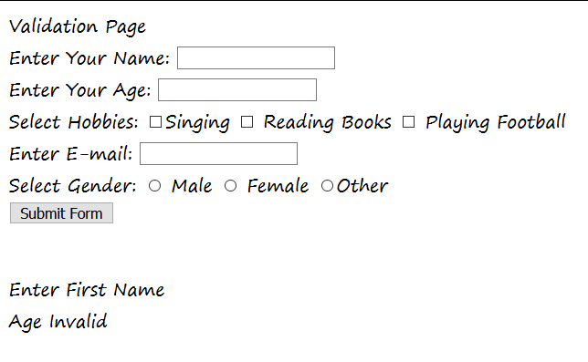

Validate.jspx

<?xml version="1.0" encoding="UTF-8"?>

<!--

Document : Validate

Created on : 30 Oct, 2020, 11:31:14 PM

Author : H310MS2

-->

<jsp:root xmlns:jsp="http://java.sun.com/JSP/Page" version="2.0">

<jsp:directive.page contentType="text/html" pageEncoding="UTF-8" import="mypack.*"/>

<!-- any content can be specified here, e.g.: -->

<jsp:element name="text">

<jsp:attribute name="lang">EN</jsp:attribute>

<jsp:body>Validation Page</jsp:body>

<jsp:useBean id="obj" scope="request" class="mypack.CheckerBean">

<jsp:setProperty name="obj" property="*"/>

<jsp:scriptlet>

if (obj.validate())

{

</jsp:scriptlet><jsp:forward page="Successful.jsp"/>

<jsp:scriptlet> }

else

{

</jsp:scriptlet>

<jsp:include page="index.html"/>

<jsp:scriptlet> }

</jsp:scriptlet>

<jsp:expression> obj.getError() </jsp:expression>

</jsp:useBean>

</jsp:element>

</jsp:root>

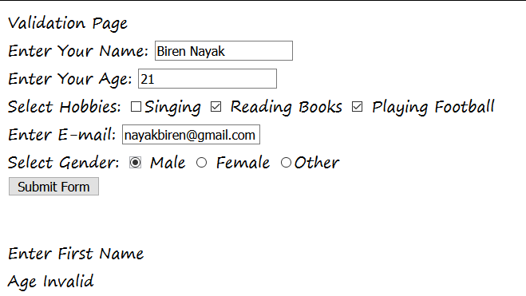

Successful.jsp

<%--

Document : Successfull

Created on : 30 Oct, 2020, 11:28:56 PM

Author : H310MS2

--%>

<%@page contentType="text/html" pageEncoding="UTF-8"%>

<!DOCTYPE html>

<html>

<head>

<meta http-equiv="Content-Type" content="text/html; charset=UTF-8">

<title>Registration Successful !!! </title>

</head>

<body>

<h1>Data validated successfully...!</h1>

</body>

</html>



CheckerBean.java

/*

* To change this license header, choose License Headers in Project Properties.

* To change this template file, choose Tools | Templates

* and open the template in the editor.

*/

package mypack;

/**

*

* @author H310MS2

*/

public class CheckerBean {

private String name, age, hob, email, gender, error;

//Constructors

public CheckerBean() { error=""; }

// setters

public void setName(String n){name=n;}

public void setAge(String a){age=a;}

public void setHob(String h){hob=h;}

public void setEmail(String e){email=e;}

public void setGender(String g){gender=g;}

public void setError(String e){error=e;}

//getters

public String getName(){return name;}

public String getAge(){return age;}

public String getHob(){return hob;}

public String getEmail(){return email;}

public String getGender(){return gender;}

public String getError(){return error;}

public boolean validate()

{

boolean res=true;

if((name==null) || name.trim().equals("") )

{

error+="<br>Enter First Name";

res=false;

}

if( (age==null) || age.length() > 2 )

{

error+="<br>Age Invalid";

res=false;

}

return res;

}

}

---------------------------------------------------------------------------------------------------------------------

1. Create a registration and login JSP application to register and authenticate the user based on username and password using JDBC.

Index.html

<!DOCTYPE html>

<!--

To change this license header, choose License Headers in Project Properties.

To change this template file, choose Tools | Templates

and open the template in the editor.

-->

<html>

<head>

<title>Login</title>

<meta charset="UTF-8">

<meta name="viewport" content="width=device-width, initial-scale=1.0">

</head>

<body>

<form action="index.jsp">

<h3>New User?<a href="Register.html" >Click here to register</a></h3>

<h3>Old User?<a href="Login.html" >Click Here to Login</a></h3>

</form>

</body>

</html>

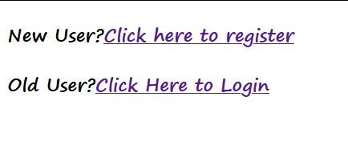

Register.html

<!DOCTYPE html>

<!--

To change this license header, choose License Headers in Project Properties.

To change this template file, choose Tools | Templates

and open the template in the editor.

-->

<html>

<head>

<title>TODO supply a title</title>

<meta charset="UTF-8">

<meta name="viewport" content="width=device-width, initial-scale=1.0">

</head>

<body>

<form action="Register.jsp" >

<h1> New User Registration Page</h1>

Enter User Name <input type="text" name="txtName" ><br>

Enter Password <input type="password" name="txtPass1" ><br>

Re-Enter Password <input type="password" name="txtPass2" ><br>

Enter Email <input type="text" name="txtEmail" ><br>

Enter Country Name <input type="text" name="txtCon" ><br>

<input type="reset" ><input type="submit" value="REGISTER" >

</form>

</body>

</html>

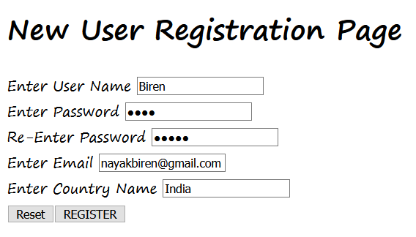

Register.jsp

<%--

Document : index

Created on : 26 Oct, 2020, 3:49:17 PM

Author : H310MS2

--%>

<%@page contentType="text/html" pageEncoding="UTF-8" import="java.sql.*"%>

<!DOCTYPE html>

<html>

<head>

<meta http-equiv="Content-Type" content="text/html; charset=UTF-8">

<title>JSP Page</title>

</head>

<body>

<%

String uname=request.getParameter("txtName");

String pass1 = request.getParameter("txtPass1");

String pass2 = request.getParameter("txtPass2");

String email = request.getParameter("txtEmail");

String ctry= request.getParameter("txtCon");

if(pass1.equals(pass2))

{

try

{

Class.forName("com.mysql.jdbc.Driver");

Connection con = DriverManager.getConnection("jdbc:mysql://localhost:3306/test","root","root");

PreparedStatement stmt= con.prepareStatement("insert into user_details values (?,?,?,?)");

stmt.setString(1, uname);

stmt.setString(2, pass1);

stmt.setString(3, email);

stmt.setString(4, ctry);

int row = stmt.executeUpdate();

if(row==1)

out.println("Registration Successfull");

else

out.println("Registration FFFFFAAAIIILLLL !!!!");

%>

<%

}

catch(Exception e)

{

out.println(e);

}

}

else{out.println("<h1>Password Mismatch</h1>");

%>

<jsp:include page="Register.html" ></jsp:include>

<% }%>

</body>

</html>

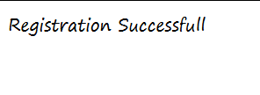

Login.html

<!DOCTYPE html>

<!--

To change this license header, choose License Headers in Project Properties.

To change this template file, choose Tools | Templates

and open the template in the editor.

-->

<html>

<head>

<title>Login Page</title>

<meta charset="UTF-8">

<meta name="viewport" content="width=device-width, initial-scale=1.0">

</head>

<body>

<form action="Login.jsp" >

Enter User Name <input type="text" name="txtName" ><br>

Enter Password <input type="password" name="txtPass"><br>

<input type="reset" >

<input type="submit" value="LOGIN" >

</form>

</body>

</html>

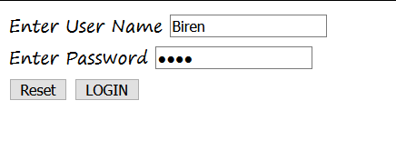

Login.jsp

<%--

Document : Login

Created on : 26 Oct, 2020, 4:09:54 PM

Author : H310MS2

--%>

<%@page contentType="text/html" pageEncoding="UTF-8" import="java.sql.*"%>

<!DOCTYPE html>

<html>

<head>

<meta http-equiv="Content-Type" content="text/html; charset=UTF-8">

<title>Login JSP Page</title>

</head>

<body>

<%

String uname = request.getParameter("txtName");

String pass = request.getParameter("txtPass");

try

{

Class.forName("com.mysql.jdbc.Driver");

Connection con = DriverManager.getConnection("jdbc:mysql://localhost:3306/test","root","root");

PreparedStatement stmt= con.prepareStatement("select password from user_details where username=?");

stmt.setString(1, uname);

ResultSet rs= stmt.executeQuery();

if(rs.next())

{

if(pass.equals(rs.getString(1)))

out.println("<h1>~~~ LOGIN SUCCESSFULLL ~~~ </h1>");

else

out.println("<h1>User Name not exist !!!!!</h1>");

%>

<%

}

}

catch(Exception e)

{

out.println(e);

}

%>

</body>

</html>

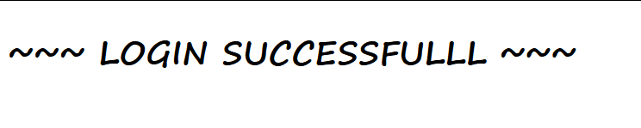

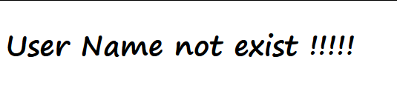

1. **Implement the following JSP JSTL and EL Applications.**
2. Create an html page with fields, eno, name, age, desg, salary. Now on submit this data to a JSP page which will update the employee table of database with matching eno.

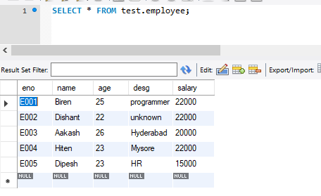

Index.html

<!DOCTYPE html>

<!--

To change this license header, choose License Headers in Project Properties.

To change this template file, choose Tools | Templates

and open the template in the editor.

-->

<html>

<head>

<title></title>

<meta charset="UTF-8">

<meta name="viewport" content="width=device-width, initial-scale=1.0">

</head>

<body>

<div style="padding: 30%">

<form action="update.jsp">

Enter Employee Number <input type="text" name="eNumber" ><br>

Enter Employee Name <input type="text" name="eName" ><br>

Enter Employee Age <input type="text" name="eAge" ><br>

Enter Employee Designation <input type="text" name="eDesignation"><br>

Enter Employee Salary <input type="text" name="eSalary" ><br>

<input type="reset" > &nbsp; <input type="submit" value="REGISTER">

</form>

</div>

</body>

</html>

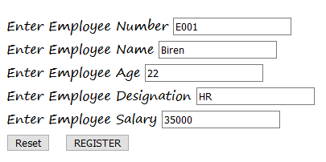

Update.jsp

<%--

Document : update

Created on : 27 Oct, 2020, 7:26:23 PM

Author : H310MS2

--%>

<%@page contentType="text/html" pageEncoding="UTF-8" import="java.sql.*"%>

<!DOCTYPE html>

<html>

<head>

<meta http-equiv="Content-Type" content="text/html; charset=UTF-8">

<title></title>

</head>

<body>

<%

String enumber = request.getParameter("eNumber");

String ename = request.getParameter("eName");

String eage = request.getParameter("eAge");

String edesignation = request.getParameter("eDesignation");

String esalary = request.getParameter("eSalary");

try

{

Class.forName("com.mysql.jdbc.Driver");

Connection con = DriverManager.getConnection("jdbc:mysql://localhost:3306/test","root","root");

PreparedStatement stmt= con.prepareStatement("update employee set desg=?, salary=? where eno=?");

stmt.setString(1,edesignation);

stmt.setString(2, esalary);

stmt.setString(3, enumber);

int row = stmt.executeUpdate();

if(row==1)

out.println("Update values Successfully");

else

out.println("Employee record does not exist");

}catch(Exception e)

{

out.println(e);

}

%>

</body>

</html>

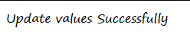

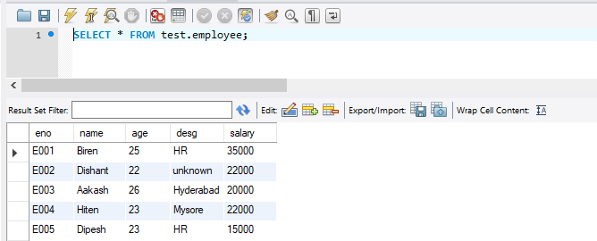

1. Create a JSP page to demonstrate the use of Expression language

Index.html

<!DOCTYPE html>

<!--

To change this license header, choose License Headers in Project Properties.

To change this template file, choose Tools | Templates

and open the template in the editor.

-->

<html>

<head>

<title>TODO supply a title</title>

<meta charset="UTF-8">

<meta name="viewport" content="width=device-width, initial-scale=1.0">

</head>

<body>

<a href="el.jsp">Click here for JSP page </a>

</body>

</html>

ej.jsp

<%--

Document : el

Created on : 27 Oct, 2020, 9:06:47 PM

Author : H310MS2

--%>

<%@page contentType="text/html" pageEncoding="UTF-8"%>

<!DOCTYPE html>

<html>

<head>

<meta http-equiv="Content-Type" content="text/html; charset=UTF-8">

<title>JSP Page</title>

</head>

<body>

<h1> Arithmetic Operations</h1>

1. The sum of 9 and 10 is ${9 + 10}. <br>

2. The difference between 10 and 25 is ${25 - 10}. <br>

3. The product of 20 and 15 is ${20 * 15}. <br>

4. The division of 25 by 500 is ${500 / 25}. <br>

5. The value of 15 mod 2 is ${15 % 2}. <br>

6. The value of 15 plus 3 times 2 is ${15+3*2}. <br>

<h1> Relational Operations</h1>

7. Evaluating the expression nine greater than ten: ${9 > 10}. <br>

8. Evaluating the expression seven less than five: ${7 < 5}. <br>

9. Evaluating the expression nine greater than or equal to ten: ${9 >= 10}. <br>

10. Evaluating the expression forty is less than equal to fifty: ${40 <= 50}. <br>

11. Evaluating the expression zero is equal to one: ${0==1} . <br>

12. Evaluating the expression five is not equal to nine:${5 != 9}. <br>

<h1> Logical Operations</h1>

13. ${ (9 > 10) and (7 > 5) }. <br>

14. ${ (40 > 50) or (7 > 10) }. <br>

15 ${ !(0 == 3) }. <br>

</body>

</html>

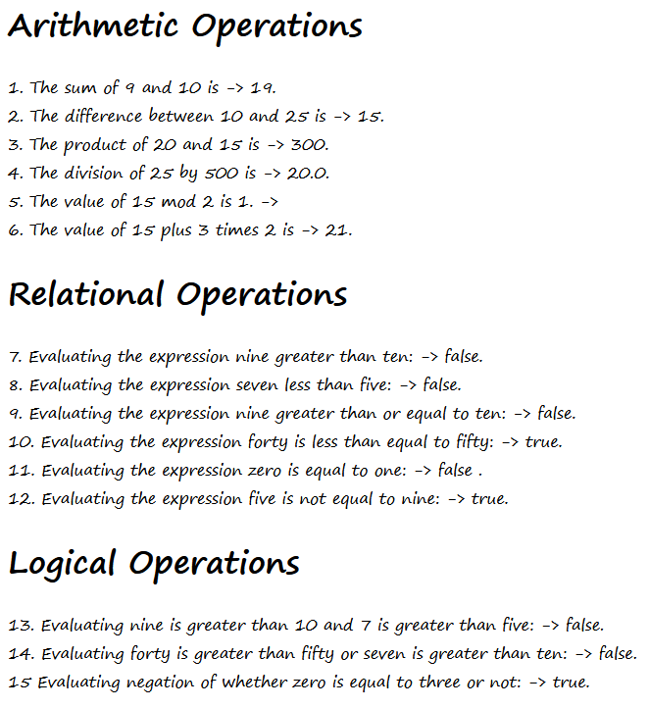

1. Create a JSP application to demonstrate the use of JSTL.

Index.html

<!DOCTYPE html>

<!--

To change this license header, choose License Headers in Project Properties.

To change this template file, choose Tools | Templates

and open the template in the editor.

-->

<html>

<head>

<title>TODO supply a title</title>

<meta charset="UTF-8">

<meta name="viewport" content="width=device-width, initial-scale=1.0">

</head>

<body>

<h1>Choose Option</h1>

<a href="insert.jsp">Insert Record</a>

<p></p>

<a href="display.jsp">Display Record</a>

</body>

</html>

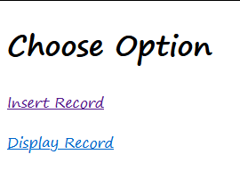

Insert.jsp

<%--

Document : insert

Created on : 2 Nov, 2020, 4:31:53 PM

Author : H310MS2

--%>

<%@page contentType="text/html" pageEncoding="UTF-8"%>

<%@ taglib uri="http://java.sun.com/jsp/jstl/core" prefix="c"%>

<!DOCTYPE html>

<html>

<head>

<meta http-equiv="Content-Type" content="text/html; charset=UTF-8">

<title>JSP Page</title>

</head>

<body>

<form action="insertdb.jsp" method="post">

<table border="0" cellspacing="2" cellpadding="5">

<thead>

<tr>

<th colspan="2">Purchase Product</th>

</tr></thead>

<tbody>

<tr>

<td>

<label>Product ID</label>

</td>

<td>

<input type="text" name="pid"/>

</td>

</tr>

<tr>

<td>

<label>Product Name</label>

</td>

<td>

<input type="text" name="pname"/>

</td>

</tr>

<tr>

<td>

<label>Quantity</label>

</td>

<td>

<input type="text" name="quantity"/>

</td>

</tr>

<tr>

<td>

<input type="submit" value="Save"/>

</td>

<td>

<input type="reset" value="reset"/>

</td>

</tr>

</tbody>

</table>

</form>

<font color="red">

<c:if test="${not empty param.errMsg}">

<c:out value="${param.errMsg}"/>

<a href="index.html">Go Back</a>

</c:if>

</font>

<font color="green">

<c:if test="${not empty param.susMsg}">

<c:out value="${param.susMsg}"/>

<a href="index.html">Go Back</a>

</c:if>

</font>

</body>

</html>

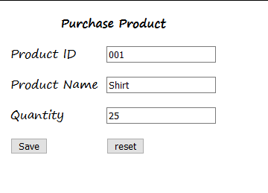

Insertdb.jsp

<%--

Document : insertdb

Created on : 2 Nov, 2020, 4:37:29 PM

Author : H310MS2

--%>

<%@page contentType="text/html" pageEncoding="UTF-8"%>

<%@ page import="java.io.*,java.util.*,java.sql.*"%>

<%@ taglib uri="http://java.sun.com/jsp/jstl/core" prefix="c"%>

<%@ taglib uri="http://java.sun.com/jsp/jstl/sql" prefix="sql"%>

<!DOCTYPE html>

<html>

<head>

<meta http-equiv="Content-Type" content="text/html; charset=UTF-8">

<title>JSP Page</title>

</head>

<body>

<c:if test="${empty param.pid or empty param.pname or empty param.quantity}">

<c:redirect url="insert.jsp">

<c:param name="errMsg" value="Please Enter Product details"/>

<img src="../../../../AppData/Local/Temp/download.jpg" alt=""/>

</c:redirect>

</c:if>

<sql:setDataSource var="dbsource" driver="com.mysql.jdbc.Driver" url="jdbc:mysql://localhost/test" user="root" password="root"/>

<sql:update dataSource="${dbsource}" var="result">INSERT INTO product_details VALUES (?,?,?);<sql:param value="${param.pid}"/>

<sql:param value="${param.pname}"/>

<sql:param value="${param.quantity}"/>

</sql:update>

<c:if test="${result>=1}">

<font size="5" color='green'> Congratulations ! Data inserted successfully.</font>

<c:redirect url="insert.jsp">

<c:param name="susMsg" value="Congratulations ! Data inserted successfully."/>

</c:redirect>

</c:if>

</body>

</html>

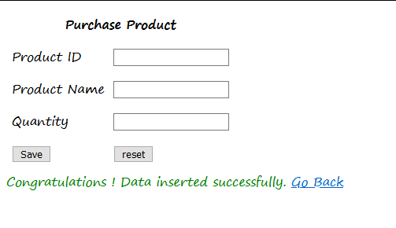

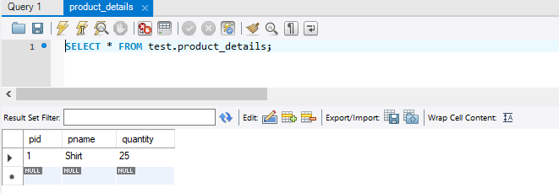

Display.jsp

<%--

Document : display

Created on : 2 Nov, 2020, 4:58:57 PM

Author : H310MS2

--%>

<%@ page import="java.io.*,java.util.*,java.sql.*"%>

<%@ taglib uri="http://java.sun.com/jsp/jstl/core" prefix="c"%>

<%@ taglib uri="http://java.sun.com/jsp/jstl/sql" prefix="sql"%>

<!DOCTYPE html>

<html>

<head>

<meta http-equiv="Content-Type" content="text/html; charset=UTF-8">

<title>JSP Page</title>

<script>

function confirmGo(m,u)

{

if ( confirm(m) )

{

window.location= u;

}

}

</script>

</head>

<body>

<sql:setDataSource var="dbsource" driver="com.mysql.jdbc.Driver" url="jdbc:mysql://localhost/test" user="root" password="root"/>

<sql:query dataSource="${dbsource}" var="result">SELECT * from product_details;

</sql:query>

<center>

<form>

<table border="1" width="40%">

<caption>Product List</caption>

<tr>

<th>Product ID</th>

<th>Product Name</th>

<th>Quantity</th>

<th colspan="2">Action</th>

</tr><c:forEach var="row" items="${result.rows}">

<tr>

<td>

<c:out value="${row.pid}"/>

</td>

<td>

<c:out value="${row.pname}"/>

</td>

<td>

<c:out value="${row.quantity}"/>

</td>

<td>

<a href="update.jsp?pid=<c:out value="${row.pid}"/>">

Update </a>

</td>

<td>

<a href="javascript:confirmGo('Sure to delete this record?','deletedb.jsp?pid=<c:out value="${row.pid}"/>')">

Delete </a>

</td>

</tr>

</c:forEach>

</table>

</form>

<a href="index.html"> Go Home </a>

</center>

</body>

</html>

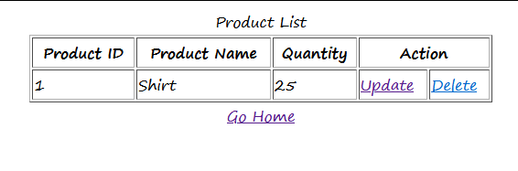

Update.jsp

<%--

Document : update

Created on : 2 Nov, 2020, 5:07:31 PM

Author : H310MS2

--%>

<%@page contentType="text/html" pageEncoding="UTF-8"%>

<%@ page import="java.io.*,java.util.*,java.sql.*"%>

<%@ taglib uri="http://java.sun.com/jsp/jstl/core" prefix="c"%>

<%@ taglib uri="http://java.sun.com/jsp/jstl/sql" prefix="sql"%>

<!DOCTYPE html>

<html>

<head>

<meta http-equiv="Content-Type" content="text/html; charset=UTF-8">

<title>JSP Page</title>

</head>

<body>

<sql:setDataSource var="dbsource" driver="com.mysql.jdbc.Driver" url="jdbc:mysql://localhost/test" user="root" password="root"/>

<sql:query dataSource="${dbsource}" var="result">

SELECT * from product_details where pid=?;

<sql:param value="${param.pid}"/>

</sql:query>

<form action="updatedb.jsp" method="post">

<table border="0" width="40%">

<caption>Update Product</caption>

<tr>

<th>Product Name</th>

<th>Quantity</th>

</tr><c:forEach var="row" items="${result.rows}">

<tr><td><input type="hidden" value="${param.pid}" name="pid"/>

<input type="text" value="${row.pname}" name="pname"/>

</td><td><input type="text" value="${row.quantity}" name="quantity"/>

</td><td><input type="submit" value="Update"/>

</td>

</tr>

</c:forEach>

</table>

<a href="index.html">Go Home</a>

</form>

</body>

</html>

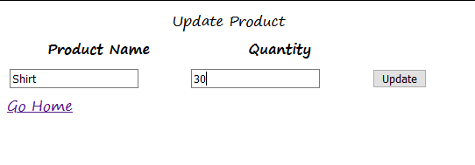

Updatedb.jsp

<%--

Document : updatedb

Created on : 2 Nov, 2020, 5:11:43 PM

Author : H310MS2

--%>

<%@page contentType="text/html" pageEncoding="UTF-8"%>

<%@ page import="java.io.*,java.util.*,java.sql.*"%>

<%@ taglib uri="http://java.sun.com/jsp/jstl/core" prefix="c"%>

<%@ taglib uri="http://java.sun.com/jsp/jstl/sql" prefix="sql"%>

<!DOCTYPE html>

<html>

<head>

<meta http-equiv="Content-Type" content="text/html; charset=UTF-8">

<title>JSP Page</title>

</head>

<body>

<sql:setDataSource var="dbsource" driver="com.mysql.jdbc.Driver" url="jdbc:mysql://localhost/test" user="root" password="root"/>

<sql:update dataSource="${dbsource}" var="count">

UPDATE product_details SET pname= ?, quantity=? WHERE pid='${param.pid}';

<sql:param value="${param.pname}"/>

<sql:param value="${param.quantity}"/>

</sql:update>

<c:if test="${count>=1}">

<font size="5" color='green'>

Congratulations ! Data updated successfully.

</font>

<a href="index.html">Go Home</a>

</c:if>

</body>

</html>



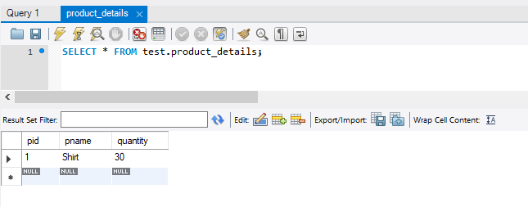



Deleted.jsp

<%--

Document : deletedb

Created on : 2 Nov, 2020, 5:15:35 PM

Author : H310MS2

--%>

<%@page contentType="text/html" pageEncoding="UTF-8"%>

<%@ page import="java.io.*,java.util.*,java.sql.*"%>

<%@ taglib uri="http://java.sun.com/jsp/jstl/core" prefix="c"%>

<%@ taglib uri="http://java.sun.com/jsp/jstl/sql" prefix="sql"%>

<!DOCTYPE html>

<html>

<head>

<meta http-equiv="Content-Type" content="text/html; charset=UTF-8">

<title>JSP Page</title>

</head>

<body>

<sql:setDataSource var="dbsource" driver="com.mysql.jdbc.Driver" url="jdbc:mysql://localhost/test" user="root" password="root"/>

<sql:update dataSource="${dbsource}" var="count">

DELETE FROM product_details WHERE pid='${param.pid}';

</sql:update>

<c:if test="${count>=1}">

<font size="5" color='green'>

Congratulations ! Data deleted successfully.

</font>

<a href="index.html">Go Home</a>

</c:if>

</body>

</html>



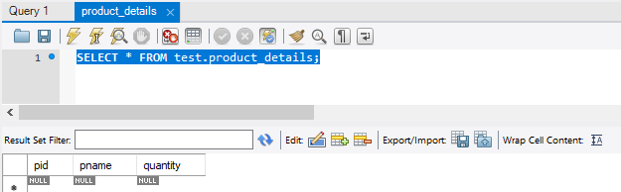

Practical 6

**6) Implement the following EJB Applications.**

a) **Aim :** Create a Currency Converter application using EJB.

**Code : index.html** <html>

<head>

<title>Currency Converter Application</title>

<meta charset="UTF-8">

<meta name="viewport" content="width=device-width, initial-scale=1.0">

</head>

<body>

<form action="CCServlet">

Enter Amount <input type="text" name="amt"><br>

Select Conversion Type:

<input type="radio" name="type" value="r2d" checked>Rupees to Dollar

<input type="radio" name="type" value="d2r">Dollor to Rupees<br>

<input type="reset" value="RESET"><input type="submit" value="CONVERT">

</form>

</body>

</html>

**CCBean.java** package mybeans; import javax.ejb.Stateless; @Stateless public class CCBean { public CCBean(){} public double r2Dollor(double r)

{

return r/74.54;

}

public double d2Rupees(double d)

{

return d*74.54;

}

}

**CCServlet.java** import java.io.IOException; import java.io.PrintWriter; import javax.ejb.EJB; import javax.servlet.ServletException; import javax.servlet.annotation.WebServlet; import javax.servlet.http.HttpServlet; import javax.servlet.http.HttpServletRequest; import javax.servlet.http.HttpServletResponse; import mybeans.CCBean;

@WebServlet(urlPatterns = {"/CCServlet"}) public class CCServlet extends HttpServlet {

@EJB

CCBean obj; protected void processRequest(HttpServletRequest request, HttpServletResponse response) throws ServletException, IOException { response.setContentType("text/html;charset=UTF-8"); try (PrintWriter out = response.getWriter()) {

/* TODO output your page here. You may use following sample code. */ out.println("<!DOCTYPE html>"); out.println("<html>"); out.println("<head>"); out.println("<title>Servlet CCServlet</title>"); out.println("</head>"); out.println("<body>"); double amt = Double.parseDouble(request.getParameter("amt")); if(request.getParameter("type").equals("r2d"))

{

out.println("<h1>"+amt+ " Rupees = "+obj.r2Dollor(amt)+" Dollors</h1>");

}

if(request.getParameter("type").equals("d2r"))

{

out.println("<h1>"+amt+ " Dollors = "+obj.d2Rupees(amt)+" Rupees</h1>");

}

out.println("</body>"); out.println("</html>");

}

**OUTPUT**

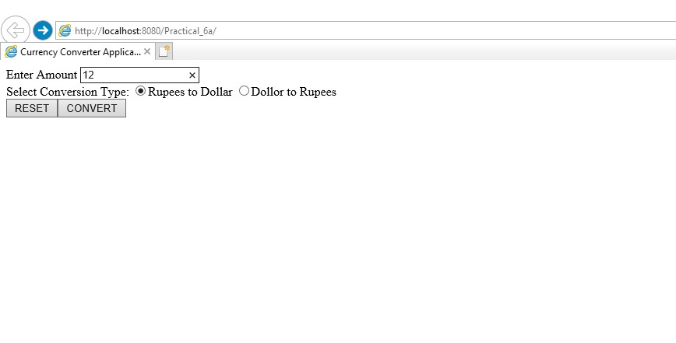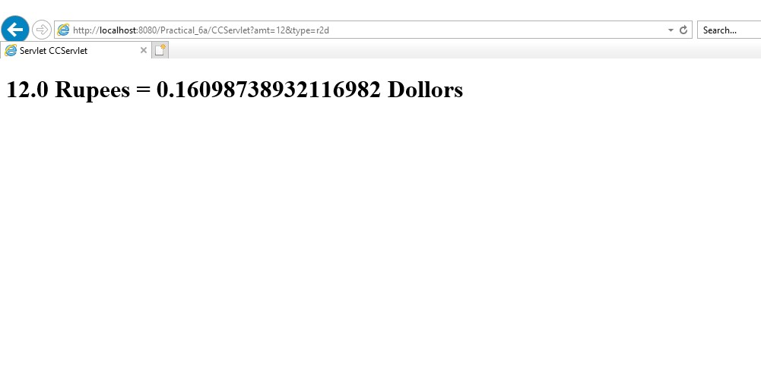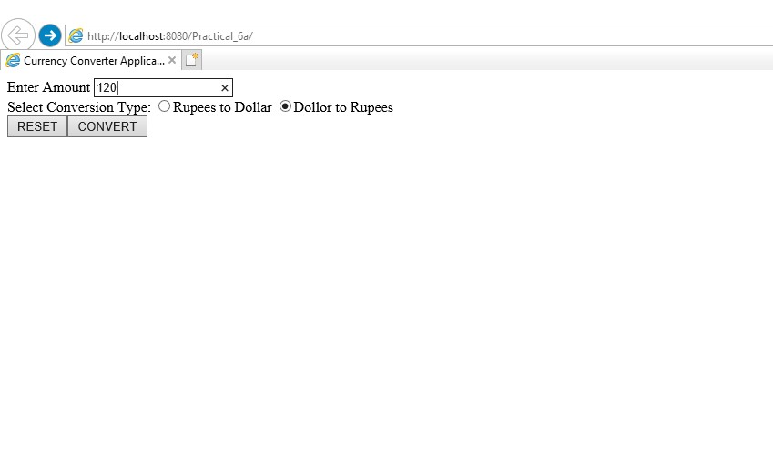

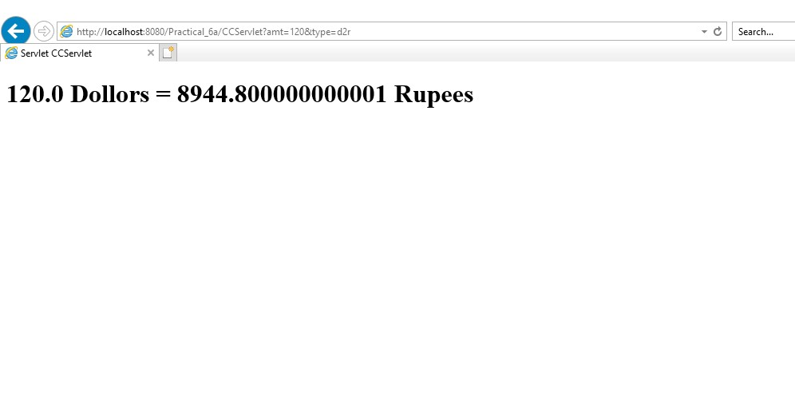

b) **Aim :** Develop a simple Room Reservation System Application using EJB.

**Code : index.html** <html>

<head>

<title>TODO supply a title</title>

<meta charset="UTF-8">

<meta name="viewport" content="width=device-width, initial-scale=1.0">

</head>

<body>

<form action="RBServlet">

Select a room type

<input type="radio" name="txtType" value="Delux">Delux

<input type="radio" name="txtType" value="Super Delux">Super Delux

<input type="radio" name="txtType" value="Suit">Suit<br>

Enter Your Name<input type="text" name="txtCust" ><br>

Enter Mobile No.<input type="text" name="txtMob" ><br>

<input type="reset" ><input type="submit" value="Book Room"> </form>

</body>

</html> **RRBean.java** package mybean;

import javax.ejb.Stateless; import java.sql.*; public class RRBean {

public RRBean(){} public String roomBook(String rt, String cn, String cm)

{

String msg="";

try{

Class.forName("com.mysql.jdbc.Driver");

Connection con =

DriverManager.getConnection("jdbc:mysql://localhost:3306/test","root","root");

String query="select * from roombook where roomtype=? and statusroom='Not Booked'";

PreparedStatement pst = con.prepareStatement(query);

pst.setString(1,rt);

ResultSet rs= pst.executeQuery();

if(rs.next()){

String rno=rs.getString(1);

PreparedStatement stm1 = con.prepareStatement("update roombook set cust=? where roomid=?");

PreparedStatement stm2 = con.prepareStatement("update roombook set mob=? where roomid=?");

PreparedStatement stm3 = con.prepareStatement("update roombook set statusroom=? where roomid=?");

stm1.setString(1,cn); stm1.setString(2,rno); stm2.setString(1,cm); stm2.setString(2,rno); stm3.setString(1, "Booked"); stm3.setString(2,rno); stm1.executeUpdate(); stm2.executeUpdate(); stm3.executeUpdate(); msg = "Room "+rno+ " Booked and Charges = "+rs.getString(3);

} else

{

msg = "Room "+rt+ " currently Not available";

}

}

catch(Exception e)

{

msg=""+e;

}

return msg;

}

}

**RBServlet.java** package mypack; import java.io.IOException; import java.io.PrintWriter; import javax.servlet.ServletException; import javax.servlet.annotation.WebServlet; import javax.servlet.http.HttpServlet; import javax.servlet.http.HttpServletRequest; import javax.servlet.http.HttpServletResponse; import mybean.RRBean; import javax.ejb.EJB;

@WebServlet(name = "RBServlet", urlPatterns = {"/RBServlet"}) public class RBServlet extends HttpServlet {

@EJB

RRBean obj; protected void processRequest(HttpServletRequest request, HttpServletResponse response) throws ServletException, IOException { response.setContentType("text/html;charset=UTF-8"); try (PrintWriter out = response.getWriter()) {

/* TODO output your page here. You may use following sample code. */ out.println("<!DOCTYPE html>"); out.println("<html>"); out.println("<head>"); out.println("<title>Servlet RBServlet</title>"); out.println("</head>"); out.println("<body>");

String rt=request.getParameter("txtType");

String cn=request.getParameter("txtCust");

String cm=request.getParameter("txtMob"); String msg = obj.roomBook(rt, cn, cm); out.println(msg); out.println("</body>"); out.println("</html>");

}

}

}

**OUTPUT**

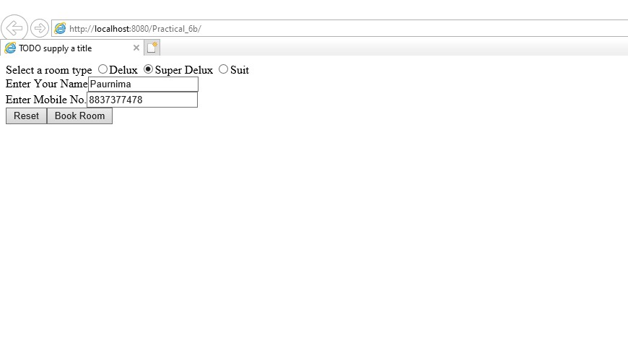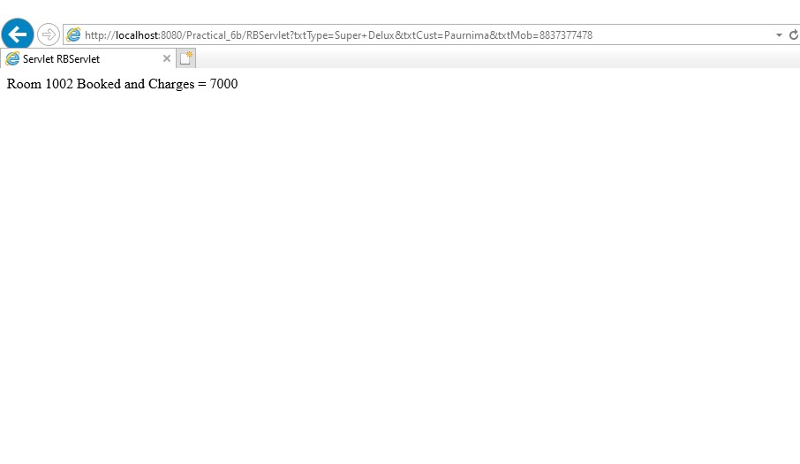

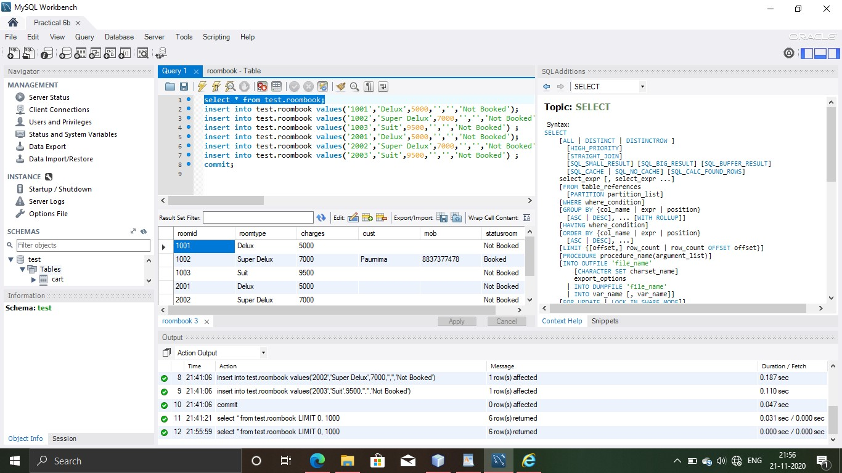

c) **Aim :**Develop a simple shopping cart application using EJB[Stateful Session Bean].

**Code : index.jsp**

<%@page import="java.util.Iterator, java.util.List, javax.naming.InitialContext, ejb.ShoppingCart"%>

<%@page contentType="text/html" pageEncoding="UTF-8"%>

<!DOCTYPE html>

<%!

private static ShoppingCart cart; public void jspInit() {

try {

InitialContext ic = new InitialContext(); cart = (ShoppingCart) ic.lookup("java:global/ShoppingCart/ShoppingCart");

}

catch (Exception ex) {

System.out.println("Could not create cart bean." + ex.getMessage());

}

}

%> <% if(request.getParameter("txtCustomerName") != null) { cart.initialize(request.getParameter("txtCustomerName"));

} else { cart.initialize("Guest");

}

if (request.getParameter("btnRmvBook") != null) { String books[] = request.getParameterValues("chkBook");

if (books != null) { for (int i=0; i<books.length; i++) { cart.removeBook(books[i]);

}

}

}

if (request.getParameter("btnAddBook") != null) { String books[] = request.getParameterValues("chkBook");

if (books != null) { for (int i=0; i<books.length; i++) { cart.addBook(books[i]);

}

}

}

%>

<html>

<head>

<meta http-equiv="Content-Type" content="text/html; charset=UTF-8">

<title>JSP Page</title>

</head>

<body style="background-color: pink;">

<h1 style="text-align: center;">Books For Sale</h1><br>

<form name="frmBooks" method="post">

<table style="background-color: pink; width: 100%; padding: 1px; border-spacing: 1px;">

<tr style="background-color: pink;">

<td style="width: 70%">

<table style="padding: 1px 1px 1px 1px; border-spacing: 1px; border: 2px solid maroon; width: 400px;">

<tr>

<td style="border: 2px solid maroon;">Customer</td>

<td style="border: 2px solid maroon;">

<input type="text" name="txtCustomerName" value=<%= request.getParameter("txtCustomerName")%> />

</td>

</tr>

<tr style="background-color: maroon;">

<th style="text-align: left; width: 340px; color: white; border: 2px solid maroon;" colspan="2">

<b>Book Titles</b>

</th>

</tr>

<tr>

<td style="border: 2px solid maroon;">

<input type="checkbox" name="chkBook" value="Struts 2.0 For Beginners">

</td>

<td style="width: 340px; border: 2px solid maroon;">Struts 2.0 For Beginners</td>

</tr>

<tr>

<td style="border: 2px solid maroon;">

<input type="checkbox" name="chkBook" value="Oracle 11g For Professionals">

</td>

<td style="width: 340px; border: 2px solid maroon;">Oracle 11g For Professionals</td>

</tr>

<tr>

<td style="border: 2px solid maroon;">

<input type="checkbox" name="chkBook" value="Hibernate 3 For Beginners">

</td>

<td style="width: 340px; border: 2px solid maroon;">Hibernate 3 For Beginners</td>

</tr>

<tr>

<td>style="border: 2px solid maroon;">

<input type="checkbox" name="chkBook" value="Java Persistence API In EJB 3 For Beginners">

</td>

<td style="width: 340px; height: 24px; border: 2px solid maroon;">Java Persistence API In EJB 3 For Beginners</td>

</tr>

<tr>

<td colspan="4" style="border: 2px solid maroon;">

<table style="background-color: pink; text-align: center;">

<tr>

<td style="text-align: center;">

<input type='submit' value='Add To My Basket' name='btnAddBook'>

</td>

<td style="text-align: center;">

<input type='submit' value='Remove From My Basket' name='btnRmvBook'>

</td>

</tr>

</table>

</td>

</tr>

</table>

</td>

<td>

<table style="border: 1px solid blue; width: 300px; height: 180px; text-align: right;">

<tr>

<td style="text-align: center; background-color: lightblue; border: 1px solid blue; height: 20px;">Basket</td>

</tr>

<%

if(cart!=null){

List<String> bookList = cart.getContents(); Iterator iterator = bookList.iterator(); while (iterator.hasNext()) {

String title = (String) iterator.next();

%>

<tr>

<td style="text-align: left; background-color: lightblue; border: 1px solid blue;"><%= title %></td>

</tr>

<%

}

}

%>

</table>

</td>

</tr>

</table>

</form>

</body>

</html>

**ShoppingCart.java** package ejb; import java.sql.Connection; import java.sql.DriverManager; import java.sql.ResultSet; import java.sql.SQLException; import java.sql.Statement; import java.util.ArrayList; import java.util.List; import javax.ejb.Remove; import javax.ejb.Stateful;

@Stateful public class ShoppingCart {

List<String> contents; String customerName; private Connection conn = null; private ResultSet rs; private Statement stmt = null; private String query = null; public void initialize(String person) { if (person != null) { customerName = person;

try {

Class.forName("com.mysql.jdbc.Driver").newInstance(); conn = DriverManager.getConnection("jdbc:mysql://localhost/test", "root", "root");

}

catch(ClassNotFoundException | IllegalAccessException | InstantiationException | SQLException e) {

System.err.println("Sorry failed to connect to the Database." + e.getMessage());

}

}

contents = new ArrayList<>();

}

public void addBook(String title) {

try {

stmt = conn.createStatement(); query = "INSERT INTO cart VALUES('" + customerName + "','" + title + "')"; stmt.executeUpdate(query);

}

catch(SQLException e) {

System.err.println("Sorry failed to insert values from the database table. " + e.getMessage());

}

}

public void removeBook(String title) {

try {

stmt = conn.createStatement();

query = "DELETE FROM cart WHERE UserName='" + customerName + "' AND ItemName='" + title + "'"; stmt.executeUpdate(query);

}

catch(SQLException e) {

System.err.println("Sorry failed to delete values from the database table. " + e.getMessage());

}

}

public List<String> getContents() {

try {

stmt = conn.createStatement(); query = "SELECT * FROM cart WHERE UserName='" + customerName + "'"; rs = stmt.executeQuery(query); while(rs.next()) { contents.add(rs.getString("ItemName"));

}

}

catch(SQLException e) {

System.err.println("Sorry failed to select values from the database table. " + e.getMessage());

}

return contents;

}

@Remove() public void remove() { contents = null;

}

}

**OUTPUT**

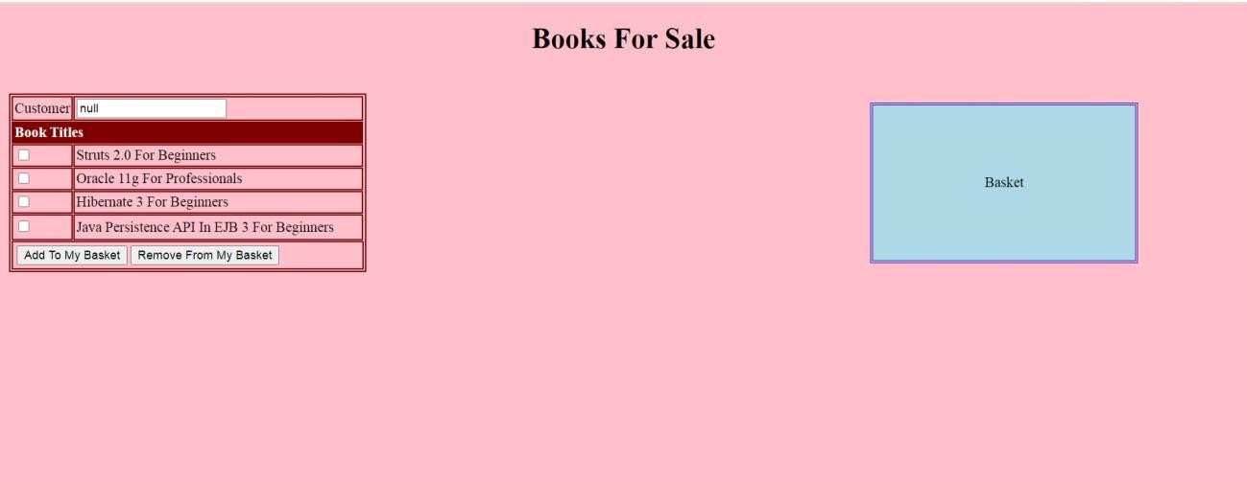

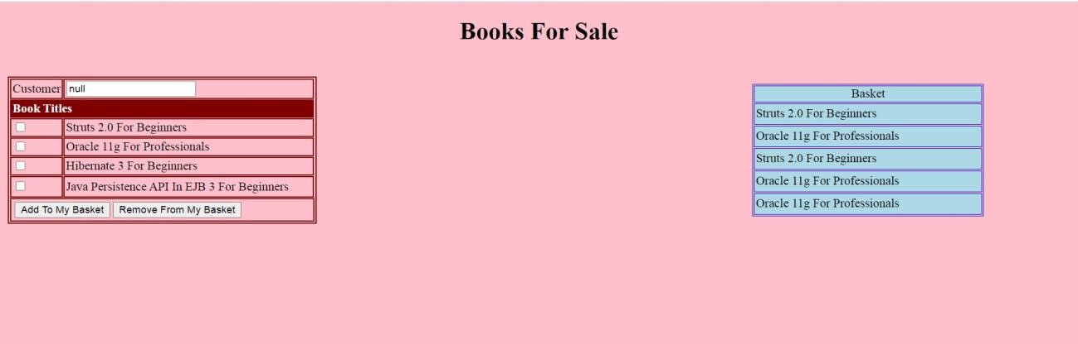

Practical 7

**7) Implement the following EJB applications with different types of Beans.**

a)**Aim :** Develop a simple EJB application to demonstrate Servlet Hit Count using Singleton session Beans.

**Code : index.html** <html>

<head>

<title>Servlet Client</title>

<meta http-equiv="Refresh" content="0; URL=ServletClient">

</head> <body>

</body>

</html>

**CountServletHitsBean.java** package ejb; import javax.ejb.Singleton;

@Singleton public class CountServletHitsBean { private int hitCount; public synchronized int incrementAndGetHitCount(){ return hitCount++;

}

}

**ServletClient.java**

package servlet; import ejb.CountServletHitsBean; import java.io.IOException; import java.io.PrintWriter; import javax.ejb.EJB; import javax.servlet.ServletException; import javax.servlet.annotation.WebServlet; import javax.servlet.http.HttpServlet; import javax.servlet.http.HttpServletRequest; import javax.servlet.http.HttpServletResponse;

@WebServlet(name = "ServletClient", urlPatterns = {"/ServletClient"}) public class ServletClient extends HttpServlet {

@EJB

CountServletHitsBean counterBean; protected void processRequest(HttpServletRequest request, HttpServletResponse response) throws ServletException, IOException { response.setContentType("text/html;charset=UTF-8"); try (PrintWriter out = response.getWriter()) {

/* TODO output your page here. You may use following sample code. */ out.println("<!DOCTYPE html>"); out.println("<html>"); out.println("<head>"); out.println("<title>Servlet ServletClient</title>"); out.println("</head>");

out.println("<body>");

out.println("<h1>Number of times this servlet is accessed:"+counterBean.incrementAndGetHitCount()+"</h1>");

out.println("</body>"); out.println("</html>");

}

}

**OUTPUT**

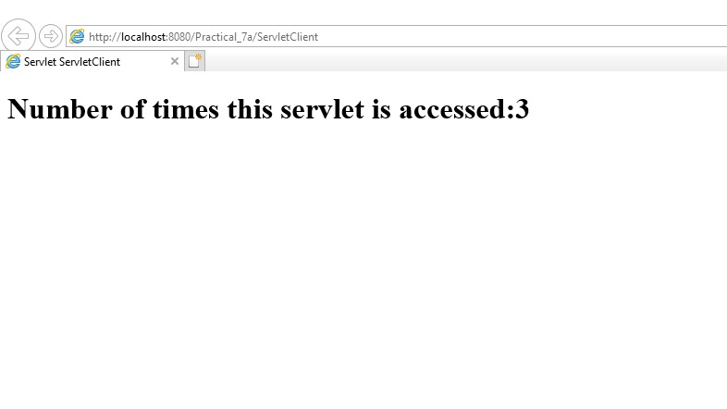

b) **Aim :** Develop simple visitors Statistics application using Message Driven Bean[Stateless Session Bean].

**Code : index.jsp**

<%@page

import="javax.jms.JMSException,javax.naming.InitialContext,javax.jms.TextMessage,javax.jms. MessageProducer,javax.jms.Session,javax.jms.Connection,javax.jms.Queue,javax.jms.Connectio nFactory"%>"

<%@page contentType="text/html" pageEncoding="UTF-8"%>

<!DOCTYPE html>

<%!

private static ConnectionFactory connectionFactory; private static Queue queue;

Connection connection =null;

Session mysession=null;

MessageProducer messageProducer=null;

TextMessage message=null;

%>

<html>

<head>

<meta http-equiv="Content-Type" content="text/html; charset=UTF-8">

<title>Welcome to Home Page</title>

</head>

<body style=background-color:blue;>

<h1>Welcome to Home Page</h1>

<% try{

InitialContext ctx = new InitialContext(); queue=(Queue)ctx.lookup("jms/Queue2"); connectionFactory=(ConnectionFactory)ctx.lookup("jms/QueueFactory"); connection=connectionFactory.createConnection(); mysession=connection.createSession(false,Session.AUTO_ACKNOWLEDGE); messageProducer=mysession.createProducer(queue); message=mysession.createTextMessage(); message.setText(request.getRemoteAddr()); messageProducer.send(message);

}

catch(JMSException e){

System.out.println("Exception occurred:"+e.toString());

}

%>

</body>

</html>

**VisitorStatBean.java** package ejb; import java.sql.Connection; import java.sql.DriverManager; import java.sql.ResultSet; import java.sql.SQLException; import java.sql.Statement; import javax.annotation.PostConstruct; import javax.annotation.PreDestroy; import javax.ejb.Stateless; @Stateless public class VisitorStatBean {

// Add business logic below. (Right-click in editor and choose

// "Insert Code > Add Business Method")

private Connection conn=null; private ResultSet rs; private Statement stmt=null; private String query=null;

@PostConstruct public void connect(){

try{

Class.forName("com.mysql.jdbc.Driver").newInstance(); conn=DriverManager.getConnection("jdbc:mysql://localhost:3306/test","root","root");

System.out.println("DataBase connection established successfully");

}

catch(ClassNotFoundException |InstantiationException |IllegalAccessException |SQLException e){

System.err.println("Sorry failed to connect to the DataBase");

}

}

@PreDestroy public void disconnect()

{ try{ conn.close();

System.out.println("DataBase connection Closed Successfully");

}

catch(SQLException e)

{

System.err.println("Cannot close the database connection:"+e.getMessage());

}

}

public void addVisitor(String host)

{ try{

stmt=conn.createStatement(); query="Insert into test.userstat Values('"+host+"','1')"; stmt.executeUpdate(query);

}

catch(SQLException e)

{ try{

stmt=conn.createStatement(); query="Update test.userstat set visits=visits+1 where hostname='"+host+"'"; stmt.executeUpdate(query);

}

catch(SQLException ex){

System.err.println("Cannot update:"+ex.getMessage());

}

}

}

}

**BasicMessageBean.java** package ejb; import javax.annotation.Resource; import javax.ejb.ActivationConfigProperty; import javax.ejb.EJB; import javax.ejb.MessageDriven; import javax.ejb.MessageDrivenContext; import javax.jms.JMSException; import javax.jms.Message; import javax.jms.MessageListener; import javax.jms.TextMessage;

@MessageDriven(activationConfig = {

@ActivationConfigProperty(propertyName = "destinationLookup", propertyValue = "jms/Queue2")

,

@ActivationConfigProperty(propertyName = "destinationType", propertyValue = "javax.jms.Queue")

})

public class BasicMessageBean implements MessageListener {

@EJB

VisitorStatBean vs;

@Resource private MessageDrivenContext mdc; public BasicMessageBean() {

}

@Override public void onMessage(Message message) {

try{

if(message instanceof TextMessage){ TextMessage msg=(TextMessage)message; vs.addVisitor(msg.getText());

}

}

catch(JMSException e)

{

mdc.setRollbackOnly();

}

}

}

**OUTPUT**

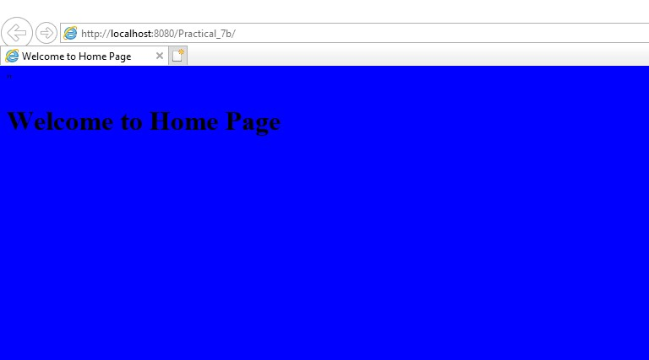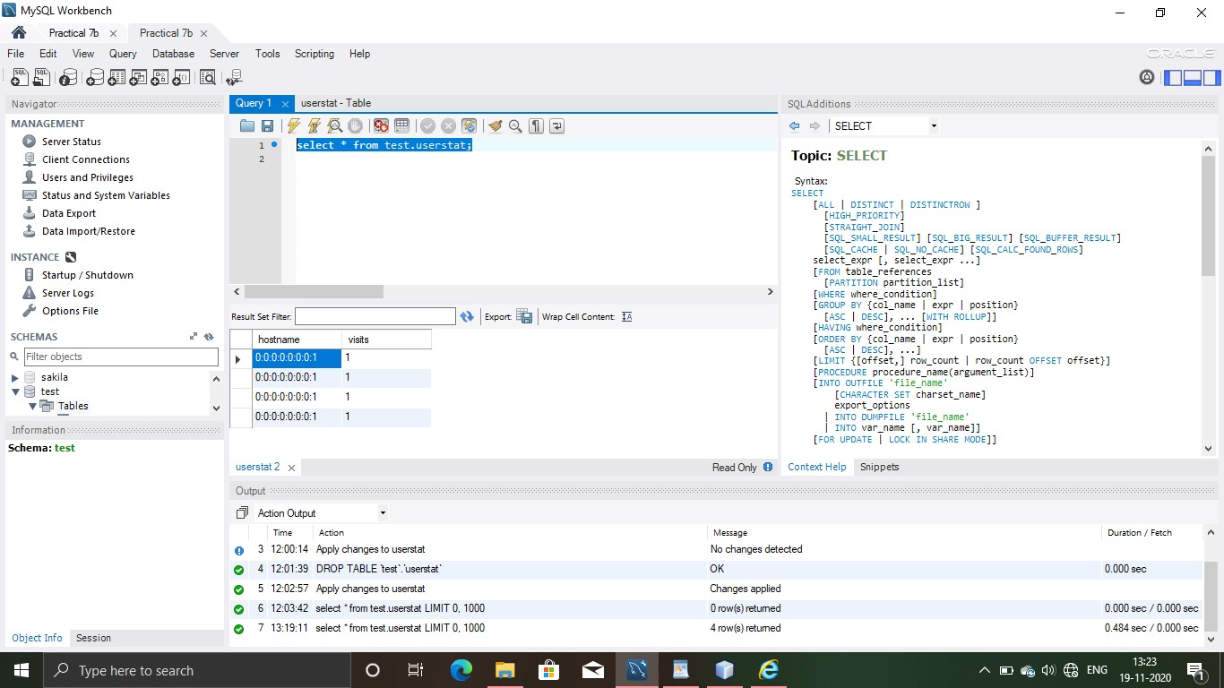

c) **Aim :** Develop simple Marks Entry Application to demonstrate accessing DataBase using EJB.

**Code : index.html** <html>

<head>

<title>TODO supply a title</title>

<meta charset="UTF-8">

<meta name="viewport" content="width=device-width, initial-scale=1.0">

</head>

<body>

<form action="marksServlet">

Enter student details :<br>

Enter SAP ID :<input type="text" name="sapid"><br>

Enter Subject :<input type="text" name="studsubject"><br>

Enter Marks :<input type="text" name="studmarks"><br>

<input type="reset" value="Reset"><input type="submit" value="Submit">

</form>

</body>

</html>

**marksServlet.java** package mypack;

import java.io.IOException; import java.io.PrintWriter; import javax.servlet.ServletException; import javax.servlet.annotation.WebServlet; import javax.servlet.http.HttpServlet; import javax.servlet.http.HttpServletRequest; import javax.servlet.http.HttpServletResponse; import mybean.StudentBean;

import javax.ejb.EJB;

@WebServlet(name = "marksServlet", urlPatterns = {"/marksServlet"}) public class marksServlet extends HttpServlet {

@EJB

StudentBean obj; protected void processRequest(HttpServletRequest request, HttpServletResponse response) throws ServletException, IOException { response.setContentType("text/html;charset=UTF-8"); try (PrintWriter out = response.getWriter()) {

/* TODO output your page here. You may use following sample code. */ out.println("<!DOCTYPE html>");

out.println("<html>");

out.println("<head>");

out.println("<title>Servlet marksServlet</title>"); out.println("</head>");

out.println("<body>");

String sa=request.getParameter("sapid");

String su=request.getParameter("studsubject");

String ma=request.getParameter("studmarks"); String msg=obj.enterStudDetails(sa,su,ma); out.println(msg);

out.println("</body>");

out.println("</html>");

}

}

**StudentBean.java** package mybean;

import javax.ejb.Stateless; import java.sql.*; @Stateless public class StudentBean { public StudentBean()

{

}

public String enterStudDetails(String sa,String su,String ma)

{

String msg="";

try{

Class.forName("com.mysql.jdbc.Driver");

Connection

con=DriverManager.getConnection("jdbc:mysql://localhost:3306/test","root","root");

PreparedStatement stmt=con.prepareStatement("insert into test.studentdata values(?,?,?)");

stmt.setString(1,sa);

stmt.setString(2,su);

stmt.setString(3,ma);

stmt.executeUpdate();

msg="Student Record inserted Successfully";

}

catch(Exception e)

{

msg=""+e;

}

return msg;

}

}

**OUTPUT**

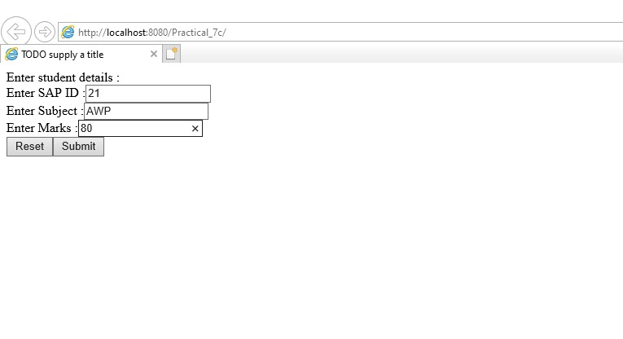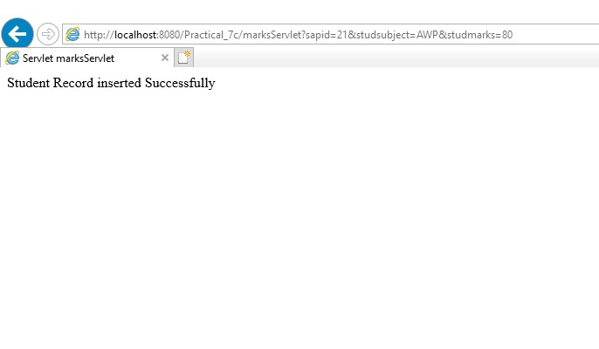

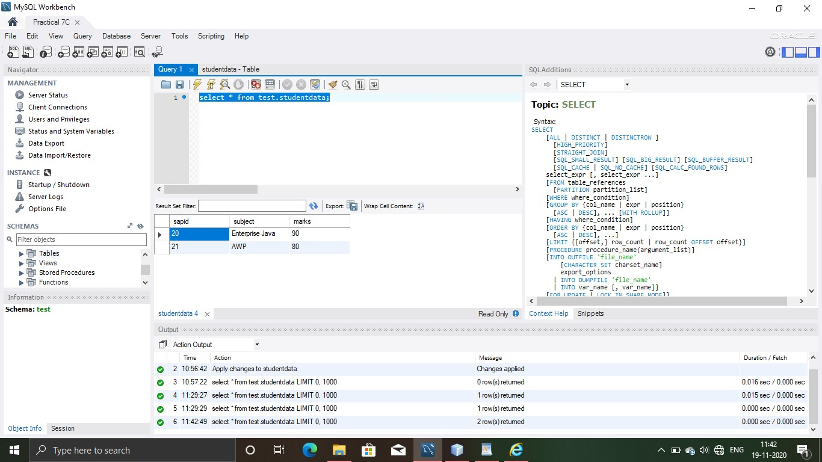

Practical 8

**8) Implement the following JPA applications.**

a) **Aim :** Develop a Inventory Application using JPA.

**Code : Practical8a.java** package practical_8a; import java.util.List; import javax.persistence.EntityManager; import javax.persistence.EntityManagerFactory; import javax.persistence.Persistence;

public class Practical8a { private ProductManager um; private EntityManager em; private EntityManagerFactory emf; private static final Inventory user1 = new Inventory(11,"Pen","40"); private static final Inventory user2 = new Inventory(22,"Pencil","30"); protected void setUp() throws Exception { emf = Persistence.createEntityManagerFactory("Practical8aPU"); em = emf.createEntityManager(); um = new ProductManager(emf);

}

public void test() {

um.createUser(user1);

Inventory user = um.searchById(1);

System.out.println("After creation of new book in table"); System.out.println("Product ID: " + user.getProductid()); user.setName("Let us C"); um.updateUser(user);

//user = um.searchById(1);

System.out.println("After update.");

System.out.println("Name of Product :" + user.getName());

System.out.println("Price : " + user.getPrice()); System.out.println("Adding one more record"); um.createUser(user2);

List list = um.getAll();

System.out.println("Number of Products: " + list.size());

}

protected void close() throws Exception { um.close(); em.close(); emf.close();

}

public static void main(String[] args) {

System.out.println("Inside TestJPA main"); Practical8a testJPA = new Practical8a();

try {

testJPA.setUp(); testJPA.test(); testJPA.close();

}

catch (Exception e) {

//e.printStackTrace();

}

System.out.println("End of TestJPA main");

}

}

**Inventory.java** package practical_8a;

import java.io.Serializable; import javax.persistence.Basic; import javax.persistence.Column; import javax.persistence.Entity; import javax.persistence.Id; import javax.persistence.NamedQueries; import javax.persistence.NamedQuery; import javax.persistence.Table; import javax.xml.bind.annotation.XmlRootElement;

@Entity

@Table(name = "inventory")

@XmlRootElement

@NamedQueries({

@NamedQuery(name = "Inventory.findAll", query = "SELECT i FROM Inventory i")

, @NamedQuery(name = "Inventory.findByProductid", query = "SELECT i FROM Inventory i WHERE i.productid = :productid")

, @NamedQuery(name = "Inventory.findByName", query = "SELECT i FROM Inventory i WHERE i.name = :name")

, @NamedQuery(name = "Inventory.findByPrice", query = "SELECT i FROM Inventory i WHERE i.price = :price")}) public class Inventory implements Serializable {

private static final long serialVersionUID = 1L;

@Id

@Basic(optional = false)

@Column(name = "productid") private Integer productid; @Column(name = "name") private String name; @Column(name = "price")

private String price;

public Inventory() {

}

public Inventory(Integer productid,String name,String price) { this.productid = productid; this.name=name; this.price=price;

}

public Integer getProductid() { return productid;

}

public void setProductid(Integer productid) { this.productid = productid;

}

public String getName() { return name;

}

public void setName(String name) { this.name = name;

}

public String getPrice() { return price;

}

public void setPrice(String price) { this.price = price;

}

@Override public int hashCode() { int hash = 0; hash += (productid != null ? productid.hashCode() : 0); return hash;

}

@Override public boolean equals(Object object) {

// TODO: Warning - this method won't work in the case the id fields are not set if (!(object instanceof Inventory)) { return false;

}

Inventory other = (Inventory) object;

if ((this.productid == null && other.productid != null) || (this.productid != null &&

!this.productid.equals(other.productid))) {

return false;

}

return true;

}

@Override public String toString() { return "practical_8a.Inventory[ productid=" + productid + " ]";

}

}

**ProductManager.java** package practical_8a; import java.util.List; import javax.persistence.EntityManager; import javax.persistence.EntityManagerFactory; import javax.persistence.Query;

public class ProductManager { private EntityManager em; public ProductManager(EntityManagerFactory emf) { em = emf.createEntityManager();

}

public void createUser(Inventory user) { em.getTransaction().begin(); em.persist(user); em.getTransaction().commit();

}

public Inventory searchById(Integer id) { return em.find(Inventory.class, id);

}

public void updateUser(Inventory user) { em.getTransaction().begin(); em.merge(user); em.getTransaction().commit();

}

public void removeUser(Inventory user) { em.getTransaction().begin(); em.remove(user); em.getTransaction().commit();

}

public List getAll() {

Query query = em.createQuery("select a from Inventory a"); List list = query.getResultList(); return list;

}

public void close() { em.close();

}

}

**OUTPUT**

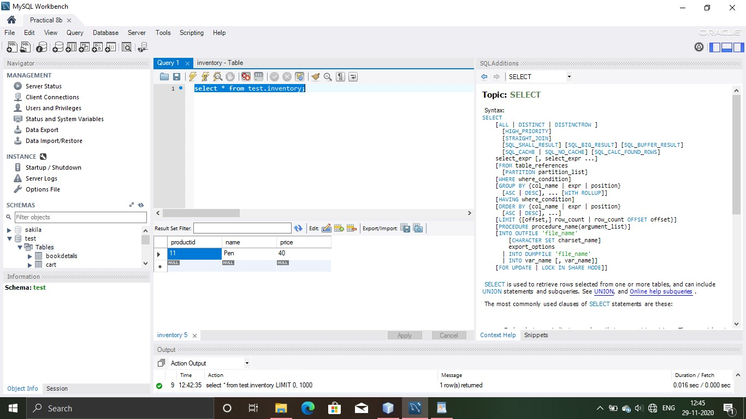

b) **Aim :** Develop a GuestBook Application using JPA.

**Code : Practical8b.java** package practical.pkg8b; import java.util.List; import javax.persistence.EntityManager; import javax.persistence.EntityManagerFactory; import javax.persistence.Persistence; public class Practical8b { private GuestManager um;

private EntityManager em; private EntityManagerFactory emf; private static final Guestdetails user1 = new Guestdetails(102,"Vaishali","Mehta"); private static final Guestdetails user2 = new Guestdetails(202,"Shubh","Bharadwaj"); protected void setUp() throws Exception { emf = Persistence.createEntityManagerFactory("Practical8bPU"); em = emf.createEntityManager(); um = new GuestManager(emf);

}

public void test() { um.createUser(user1);

Guestdetails user = um.searchById(1);

System.out.println("After creation of new book in table"); System.out.println("Guest ID: " + user.getGuestid()); user.setName("Let us C"); um.updateUser(user);

//user = um.searchById(1);

System.out.println("After update.");

System.out.println("Name of Guest :" + user.getName());

System.out.println("Surname : " + user.getSurname()); System.out.println("Adding one more record"); um.createUser(user2);

List list = um.getAll();

System.out.println("Number of guests: " + list.size());

}

protected void close() throws Exception { um.close(); em.close(); emf.close();

}

public static void main(String[] args) {

System.out.println("Inside TestJPA main"); Practical8b testJPA = new Practical8b();

try { testJPA.setUp(); testJPA.test(); testJPA.close();

}

catch (Exception e) {

//e.printStackTrace();

}

System.out.println("End of TestJPA main");

}

}

**Guestdetails.java** package practical.pkg8b; import java.io.Serializable; import javax.persistence.Basic; import javax.persistence.Column; import javax.persistence.Entity; import javax.persistence.Id; import javax.persistence.NamedQueries; import javax.persistence.NamedQuery; import javax.persistence.Table; import javax.xml.bind.annotation.XmlRootElement;

@Entity

@Table(name = "guestdetails")

@XmlRootElement

@NamedQueries({

@NamedQuery(name = "Guestdetails.findAll", query = "SELECT g FROM Guestdetails g")

, @NamedQuery(name = "Guestdetails.findByGuestid", query = "SELECT g FROM Guestdetails g WHERE g.guestid = :guestid")

, @NamedQuery(name = "Guestdetails.findByName", query = "SELECT g FROM Guestdetails g WHERE g.name = :name")

, @NamedQuery(name = "Guestdetails.findBySurname", query = "SELECT g FROM Guestdetails g WHERE g.surname = :surname")}) public class Guestdetails implements Serializable {

private static final long serialVersionUID = 1L;

@Id

@Basic(optional = false)

@Column(name = "guestid")

private Integer guestid; @Column(name = "name") private String name;

@Column(name = "surname") private String surname;

public Guestdetails() {

}

public Guestdetails(Integer guestid,String name,String surname) { this.guestid = guestid; this.name=name; this.surname=surname;

}

public Integer getGuestid() { return guestid;

}

public void setGuestid(Integer guestid) { this.guestid = guestid;

}

public String getName() { return name;

}

public void setName(String name) { this.name = name;

}

public String getSurname() { return surname;

}

public void setSurname(String surname) { this.surname = surname;

}

@Override public int hashCode() { int hash = 0; hash += (guestid != null ? guestid.hashCode() : 0); return hash;

}

@Override

public boolean equals(Object object) {

// TODO: Warning - this method won't work in the case the id fields are not set if (!(object instanceof Guestdetails)) { return false;

}

Guestdetails other = (Guestdetails) object;

if ((this.guestid == null && other.guestid != null) || (this.guestid != null &&

!this.guestid.equals(other.guestid))) {

return false;

}

return true;

}

@Override public String toString() { return "practical.pkg8b.Guestdetails[ guestid=" + guestid + " ]";

}

}

**GuestManager.java** package practical.pkg8b; import java.util.List; import javax.persistence.EntityManager; import javax.persistence.EntityManagerFactory; import javax.persistence.Query;

public class GuestManager { private EntityManager em; public GuestManager(EntityManagerFactory emf) { em = emf.createEntityManager();

}

public void createUser(Guestdetails user) { em.getTransaction().begin(); em.persist(user); em.getTransaction().commit();

}

public Guestdetails searchById(Integer id) { return em.find(Guestdetails.class, id);

}

public void updateUser(Guestdetails user) { em.getTransaction().begin(); em.merge(user); em.getTransaction().commit();

}

public void removeUser(Guestdetails user) { em.getTransaction().begin(); em.remove(user); em.getTransaction().commit();

} public List getAll() {

Query query = em.createQuery("select a from Guestdetails a"); List list = query.getResultList(); return list;

}

public void close() { em.close();

}

}

**OUTPUT**

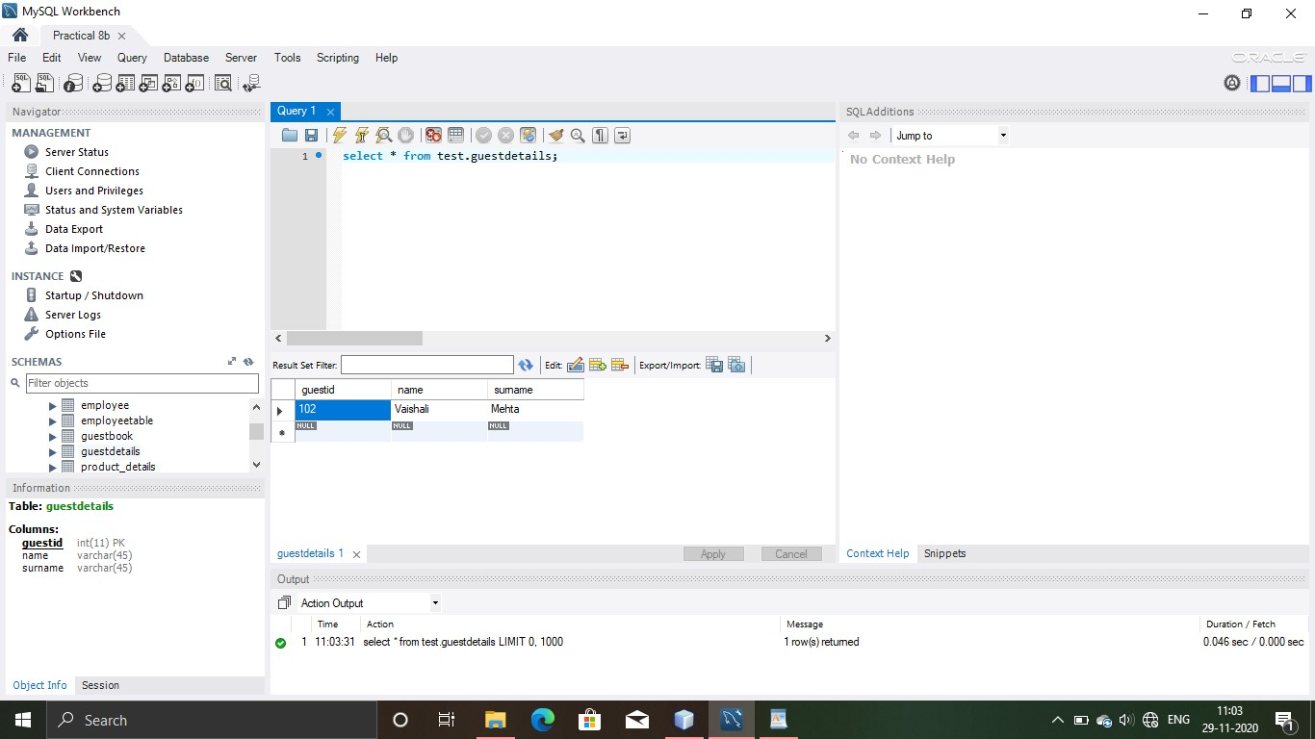

c) **Aim :** Create simple JPA application to store and retrieve Book details.

**Code :**

**Practical8c.java** package practical.pkg8c; import java.util.List; import javax.persistence.EntityManager; import javax.persistence.EntityManagerFactory; import javax.persistence.Persistence; public class Practical8c {

private BookManager um; private EntityManager em; private EntityManagerFactory emf;

private static final Bookdetails user1 = new Bookdetails(1102, "Enterprise Java","Vaishali Shah"); private static final Bookdetails user2 = new Bookdetails(2202, "Java","Kanetkar"); protected void setUp() throws Exception { emf = Persistence.createEntityManagerFactory("Practical_8cPU"); em = emf.createEntityManager(); um = new BookManager(emf);

}

protected void close() throws Exception { um.close(); em.close(); emf.close();

}

public void test() { um.createUser(user1);

Bookdetails user = um.searchById(1);

System.out.println("After creation of new book in table"); System.out.println("Book ID: " + user.getBookid()); user.setBooktitle("Let us C"); um.updateUser(user);

System.out.println("After update.");

System.out.println("Title of the Book " + user.getBooktitle());

System.out.println("Author: " + user.getBookauthor()); System.out.println("Adding one more record"); um.createUser(user2);

List list = um.getAll();

System.out.println("Number of books: " + list.size());

}

public static void main(String[] args) {

// TODO code application logic here

System.out.println("Inside TestJPA main"); Practical8c testJPA = new Practical8c();

try { testJPA.setUp(); testJPA.test(); testJPA.close();

}

catch (Exception e) {

//e.printStackTrace();

}

System.out.println("End of TestJPA main");

}

}

**Bookdetails.java** package practical.pkg8c;

import java.io.Serializable; import javax.persistence.Basic; import javax.persistence.Column; import javax.persistence.Entity; import javax.persistence.Id; import javax.persistence.NamedQueries; import javax.persistence.NamedQuery; import javax.persistence.Table; import javax.xml.bind.annotation.XmlRootElement;

@Entity

@Table(name = "bookdetails")

@XmlRootElement

@NamedQueries({

@NamedQuery(name = "Bookdetails.findAll", query = "SELECT b FROM Bookdetails b") , @NamedQuery(name = "Bookdetails.findByBookid", query = "SELECT b FROM Bookdetails b

WHERE b.bookid = :bookid")

, @NamedQuery(name = "Bookdetails.findByBooktitle", query = "SELECT b FROM Bookdetails b WHERE b.booktitle = :booktitle")

, @NamedQuery(name = "Bookdetails.findByBookauthor", query = "SELECT b FROM Bookdetails b WHERE b.bookauthor = :bookauthor")}) public class Bookdetails implements Serializable {

private static final long serialVersionUID = 1L;

@Id

@Basic(optional = false)

@Column(name = "bookid") private Integer bookid; @Column(name = "booktitle") private String booktitle;

@Column(name = "bookauthor") private String bookauthor;

public Bookdetails() {

}

public Bookdetails(Integer bookid,String booktitle,String bookauthor) { this.bookid = bookid; this.booktitle = booktitle; this.bookauthor = bookauthor;

}

public Integer getBookid() { return bookid;

}

public void setBookid(Integer bookid) { this.bookid = bookid;

}

public String getBooktitle() { return booktitle;

}

public void setBooktitle(String booktitle) { this.booktitle = booktitle;

}

public String getBookauthor() { return bookauthor;

}

public void setBookauthor(String bookauthor) { this.bookauthor = bookauthor;

}

@Override public int hashCode() { int hash = 0; hash += (bookid != null ? bookid.hashCode() : 0); return hash;

}

@Override public boolean equals(Object object) {

// TODO: Warning - this method won't work in the case the id fields are not set if (!(object instanceof Bookdetails)) { return false;

}

Bookdetails other = (Bookdetails) object;

if((this.bookid == null && other.bookid != null) || (this.bookid != null &&

!this.bookid.equals(other.bookid))){

return false;

}

return true;

}

@Override public String toString() { return "practical.pkg8c.Bookdetails[ bookid=" + bookid + " ]";

}

}

**BookManager.java** package practical.pkg8c; import java.util.List; import javax.persistence.EntityManager; import javax.persistence.EntityManagerFactory; import javax.persistence.Query; public class BookManager { private EntityManager em; public BookManager(EntityManagerFactory emf) { em = emf.createEntityManager();

}

public void createUser(Bookdetails user) { em.getTransaction().begin(); em.persist(user); em.getTransaction().commit();

}

public Bookdetails searchById(Integer id) { return em.find(Bookdetails.class, id);

}

public void updateUser(Bookdetails user){ em.getTransaction().begin(); em.merge(user); em.getTransaction().commit();

}

public void removeUser(Bookdetails user) { em.getTransaction().begin(); em.remove(user); em.getTransaction().commit();

}

public List getAll() {

Query query = em.createQuery("select a from Bookdetails a"); List list = query.getResultList(); return list;

}

public void close() { em.close();

}

}

**OUTPUT**

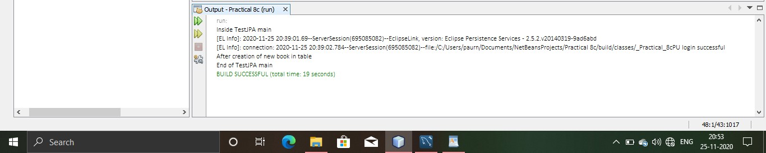

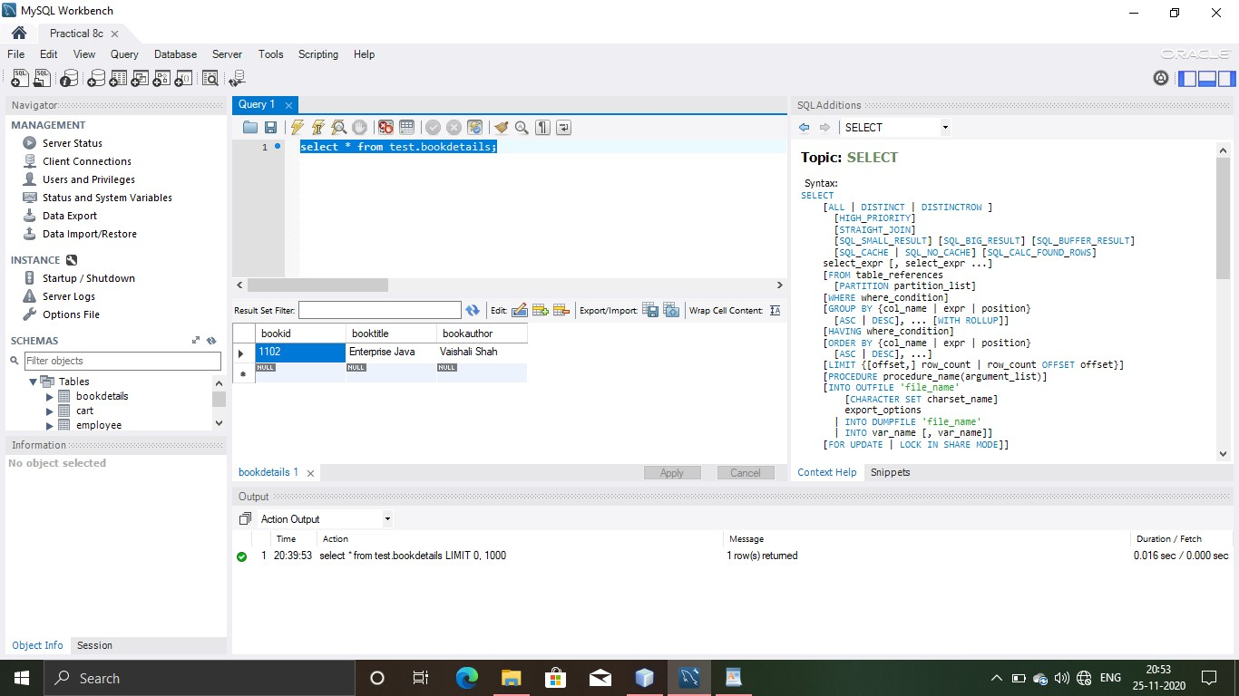

Practical 9

**9) Implement the following JPA applications with ORM and Hibernate.**

b) **Aim :** Develop a hibernate application to store feedback of Website visitor in MySQL Database.

**Code : GuestBook.java** package myApp; import javax.persistence.Column; import javax.persistence.Entity; import javax.persistence.GeneratedValue; import javax.persistence.Id; import javax.persistence.Table;

@Entity

@Table(name="guestbook") public class GuestBook implements java.io.Serializable{

@Id

@GeneratedValue

@Column(name="VisitorNo") private Integer visitorNo;

@Column(name="VisitorName") private String visitorName; @Column(name="Message")

private String message;

@Column(name="MessageDate") private String messageDate; public GuestBook() {

}

public GuestBook(String visitorName, String message, String messageDate) { this.visitorName = visitorName; this.message = message; this.messageDate = messageDate;

}

public Integer getVisitorNo() { return visitorNo;

}

public void setVisitorNo(Integer visitorNo) { this.visitorNo = visitorNo;

}

public String getVisitorName() { return visitorName;

}

public void setVisitorName(String visitorName) { this.visitorName = visitorName;

}

public String getMessage() { return message;

}

public void setMessage(String message) { this.message = message;

}

public String getMessageDate() { return messageDate;

}

public void setMessageDate(String messageDate) { this.messageDate = messageDate;

}

}

**hibernate.cfg.xml**

<hibernate-configuration>

<session-factory>

<property name="hibernate.dialect">org.hibernate.dialect.MySQLDialect</property>

<property name="hibernate.connection.driver_class">com.mysql.jdbc.Driver</property>

<property

name="hibernate.connection.url">jdbc:mysql://localhost:3306/test?zeroDateTimeBehavior=co nvertToNull</property>

<property name="hibernate.connection.username">root</property>

<property name="hibernate.connection.password">root</property>

<mapping class="myApp.GuestBook"/>

</session-factory>

</hibernate-configuration>

**index.jsp**

<%@page contentType="text/html" pageEncoding="UTF-8"%>

<!DOCTYPE html>

<html>

<head>

<meta http-equiv="Content-Type" content="text/html; charset=UTF-8">

<title>JSP Page</title>

</head>

<body style="background-color: pink;">

<table style="width: 100%; alignment-adjust: central; border: 0px;">

<tr>

<td>

<table style="width: 100%; border: 0px;">

<tr>

<td style="text-align: left; vertical-align: middle; padding-right:0px; paddingleft:0px; paddingbottom:0px; font:24px/30px Georgia; width:228px; color:#786e4e; paddingtop:0px; height:37px;">

Sign the Guest Book

</td>

</tr>

</table>

</td>

</tr>

<tr style="text-align: left; vertical-align: top;">

<td style="height: 20px;"><hr /></td>

</tr>

<tr>

<td>

<form action="GuestBookView.jsp" method="post">

<table style="border-spacing: 2px; border: 0px;">

<tr>

<td style="text-align: right; font-size:15px; font-family:Arial,Times,serif; fontweight:bold;">

Visitor Name:

</td>

<td>

<input name="guest" maxlength="25" size="50" />

</td>

</tr>

<tr>

<td style="text-align: right; font-size:15px; font-family:Arial,Times,serif; fontweight:bold;">

Message:

</td>

<td>

<textarea rows="5" cols="36" name="message"></textarea>

</td>

</tr>

<tr>

<td colspan="2" style="text-align: right;">

<input type="submit" name="btnSubmit" value="Submit" />

</td>

</tr>

</table>

</form>

</td>

</tr>

</table>

</body>

</html>

**GuestBookView.java**

<%@page

import="java.util.Iterator,org.hibernate.Transaction,org.hibernate.service.ServiceRegistryBuilde r,org.hibernate.cfg.

Configuration,org.hibernate.service.ServiceRegistry,java.util.List,myApp.GuestBook,org.hiberna te.SessionFactory"

%>

<%@page contentType="text/html" pageEncoding="UTF-8"%>

<!DOCTYPE html>

<%!

SessionFactory sessionFactory; ServiceRegistry serviceRegistry; org.hibernate.Session hibernateSession;

List<GuestBook> guestbook;

%>

<%

Configuration configuration = new Configuration(); configuration.configure();

serviceRegistry = new

ServiceRegistryBuilder().applySettings(configuration.getProperties()).buildServiceRegistry(); sessionFactory = configuration.buildSessionFactory(serviceRegistry); hibernateSession = sessionFactory.openSession();

Transaction transaction = null;

String submit = request.getParameter("btnSubmit"); if(submit != null && ("Submit").equals(submit)) { GuestBook gb = new GuestBook();

try {

transaction = hibernateSession.beginTransaction();

String guest = request.getParameter("guest");

String message = request.getParameter("message"); String messageDate = new java.util.Date().toString(); gb.setVisitorName(guest); gb.setMessage(message); gb.setMessageDate(messageDate); hibernateSession.save(gb); transaction.commit();

}

catch (RuntimeException e) { if(transaction != null) transaction.rollback(); throw e;

}

response.sendRedirect("GuestBookView.jsp");

} try {

hibernateSession.beginTransaction(); guestbook = hibernateSession.createQuery("from GuestBook").list();

}

catch (RuntimeException e) {

throw e;

}

hibernateSession.close();

%>

<html>

<head>

<meta http-equiv="Content-Type" content="text/html; charset=UTF-8">

<title>Guest Book</title>

</head>

<body style="background-color: pink;">

<table style="alignment-adjust: central; width: 100%; border: 0px;">

<tr>

<td>

<table style="width: 100%; border: 0px;">

<tr>

<td style="width: 60%; vertical-align: middle; text-align: left; padding-right:0px; padding-left:0px;

padding-bottom:0px; font:24px/30px Georgia; width:228px; color:#786e4e; padding-top:0px; height:37px;">

View the Guest Book

</td>

<td style="vertical-align: bottom; text-align: right; font:12px/16px Georgia, serif; color:#786e4e;">

<b>Click <a href="index.jsp"> here</a> to sign the guestbook.</b>

</td>

</tr>

</table>

</td>

</tr>

<tr style="text-align: left; vertical-align: top;">

<td style="height: 20px;"><hr /></td>

</tr>

<tr>

<td>

<table style="text-align: left; width: 100%; border: 0px;">

<%

Iterator iterator = guestbook.iterator(); while (iterator.hasNext()) {

GuestBook objGb = (GuestBook) iterator.next();

%>

<tr>

<td style="font:12px/16px Georgia; color:#786e4e;">

On <%=objGb.getMessageDate()%>,<br />

<b><%=objGb.getVisitorName()%>:</b>

<%=objGb.getMessage()%>

<br /><br />

</td>

</tr>

<%

}

%>

</table>

</td>

</tr>

</table>

</body>

</html>

c) **Aim :** Develop a Hibernate application to store and retrieve employee details in MySQL Database.

**Code :**

**EmployeeData.java** package empApp; import javax.persistence.Column; import javax.persistence.Entity; import javax.persistence.GeneratedValue; import javax.persistence.Id; import javax.persistence.Table;

@Entity

@Table(name="employeetable")

public class EmployeeData implements java.io.Serializable {

@Id

@GeneratedValue

@Column(name="EmployeeID") private Integer employeeID;

@Column(name="EmployeeName") private String employeeName; @Column(name="EmployeeDept") private String employeeDept; @Column(name="EmployeeSalary") private String employeeSalary; public EmployeeData() {

}

public EmployeeData(String employeeName, String employeeDept, String employeeSalary) { this.employeeName = employeeName; this.employeeDept = employeeDept; this.employeeSalary = employeeSalary;

}

public Integer getEmployeeID() { return employeeID;

}

public void setEmployeeID(Integer employeeID) { this.employeeID = employeeID;

}

public String getEmployeeName() { return employeeName;

}

public void setEmployeeName(String employeeName) { this.employeeName = employeeName;

}

public String getEmployeeDept() { return employeeDept;

}

public void setEmployeeDept(String employeeDept) { this.employeeDept = employeeDept;

}

public String getEmployeeSalary() { return employeeSalary;

}

public void setEmployeeSalary(String employeeSalary) { this.employeeSalary = employeeSalary;

}

}

**hibernate.cfg.xml**

<hibernate-configuration>

<session-factory>

<property name="hibernate.dialect">org.hibernate.dialect.MySQLDialect</property> <property name="hibernate.connection.driver_class">com.mysql.jdbc.Driver</property>

<property

name="hibernate.connection.url">jdbc:mysql://localhost:3306/test?zeroDateTimeBehavior=co nvertToNull</property>

<property name="hibernate.connection.username">root</property>

<property name="hibernate.connection.password">root</property>

<mapping class="empApp.EmployeeData"/>

</session-factory>

</hibernate-configuration>

**index.jsp**

<%@page contentType="text/html" pageEncoding="UTF-8"%>

<!DOCTYPE html>

<html>

<head>

<meta http-equiv="Content-Type" content="text/html; charset=UTF-8">

<title>Employee Data</title>

</head>

<body style="background-color:yellow;">

<table style="width: 100%; alignment-adjust: central; border: 0px;">

<tr>

<td>

<table style="width: 100%; border: 0px;">

<tr>

<td style="text-align: left;

vertical-align: middle;

padding-right:0px;

paddingleft:0px;

paddingbottom:0px;

font:24px/30px Georgia;

width:228px;

color:#786e4e;

paddingtop:0px;

height:37px;">

Add Employee Data

</td>

</tr>

</table>

</td>

</tr>

<tr style="text-align: left; vertical-align: top;">

<td style="height: 20px;"><hr /></td>

</tr>

<tr>

<td>

<form action="EmployeeDataView.jsp" method="post">

<table style="border-spacing: 2px; border: 0px;">

<tr>

<td style="text-align: right; font-size:15px; font-family:Arial,Times,serif; fontweight:bold;">

Employee Name:

</td>

<td>

<input name="employee" maxlength="25" size="50" />

</td>

</tr>

<tr>

<td style="text-align: right; font-size:15px; font-family:Arial,Times,serif; fontweight:bold;">

Employee Department:

</td>

<td>

<input name="empdept" maxlength="25" size="50" />

</td>

</tr>

<tr>

<td style="text-align: right; font-size:15px; font-family:Arial,Times,serif; fontweight:bold;">

Employee Salary:

</td>

<td>

<input name="empsal" maxlength="25" size="50" />

</td>

</tr>

<tr>

<td colspan="2" style="text-align: right;">

<input type="submit" name="btnSubmit" value="Submit" />

</td>

</tr>

</table>

</form>

</td>

</tr>

</table>

</body>

</html>

**EmployeeDataView.java**

<%@page

import="java.util.Iterator,org.hibernate.Transaction,org.hibernate.service.ServiceRegistryBuilde r,org.hibernate.cfg.

Configuration,org.hibernate.service.ServiceRegistry,java.util.List,empApp.EmployeeData,org.hib ernate.SessionFactory"

%>

<%@page contentType="text/html" pageEncoding="UTF-8"%>

<!DOCTYPE html>

<%!

SessionFactory sessionFactory; ServiceRegistry serviceRegistry; org.hibernate.Session hibernateSession;

List<EmployeeData> employeetable;

%>

<%

Configuration configuration = new Configuration(); configuration.configure();

serviceRegistry = new

ServiceRegistryBuilder().applySettings(configuration.getProperties()).buildServiceRegistry(); sessionFactory = configuration.buildSessionFactory(serviceRegistry); hibernateSession = sessionFactory.openSession();

Transaction transaction = null;

String submit = request.getParameter("btnSubmit"); if(submit != null && ("Submit").equals(submit)) { EmployeeData ed = new EmployeeData();

try {

transaction = hibernateSession.beginTransaction();

String employee = request.getParameter("employee");

String empdept = request.getParameter("empdept"); String empsal = request.getParameter("empsal"); ed.setEmployeeName(employee); ed.setEmployeeDept(empdept); ed.setEmployeeSalary(empsal); hibernateSession.save(ed); transaction.commit();

}

catch (RuntimeException e) { if(transaction != null) transaction.rollback(); throw e;

}

response.sendRedirect("EmployeeDataView.jsp");

} try {

hibernateSession.beginTransaction(); employeetable = hibernateSession.createQuery("from EmployeeData").list();

}

catch (RuntimeException e) {

throw e;

}

hibernateSession.close();

%>

<html>

<head>

<meta http-equiv="Content-Type" content="text/html; charset=UTF-8">

<title>Employee Data</title>

</head>

<body style="background-color: yellow;">

<table style="alignment-adjust: central; width: 100%; border: 0px;">

<tr>

<td>

<table style="width: 100%; border: 0px;">

<tr>

<td style="width: 60%; vertical-align: middle; text-align: left; padding-right:0px; padding-left:0px;

padding-bottom:0px; font:24px/30px Georgia; width:228px; color:#786e4e; padding-top:0px; height:37px;">

View the Employee Data

</td>

<td style="vertical-align: bottom; text-align: right; font:12px/16px Georgia, serif; color:#786e4e;">

<b>Click <a href="index.jsp"> here</a> to sign the Employee Data.</b>

</td>

</tr>

</table>

</td>

</tr>

<tr style="text-align: left; vertical-align: top;">

<td style="height: 20px;"><hr /></td>

</tr>

<tr>

<td>

<table style="text-align: left; width: 100%; border: 0px;">

<%

Iterator iterator = employeetable.iterator(); while (iterator.hasNext()) {

EmployeeData objed = (EmployeeData) iterator.next();

%>

<tr>

<td style="font:12px/16px Georgia; color:#786e4e;">

Name :<b><%=objed.getEmployeeName()%>:</b><br>

Department:<%=objed.getEmployeeDept()%><br>

Salary:<%=objed.getEmployeeSalary()%>

<br /><br />

</td>

</tr>

<%

}

%>

</table>

</td>

</tr>

</table>

</body>

</html>

Practical 10

**10) Implement the following Hibernate applications.**

b) **Aim :** Develop hibernate application to enter and retrieve course details with ORM mapping.

**Code : CourseData.java** package courseApp; import javax.persistence.Column; import javax.persistence.Entity; import javax.persistence.GeneratedValue; import javax.persistence.Id; import javax.persistence.Table;

@Entity

@Table(name="course") public class CourseData implements java.io.Serializable {

@Id

@GeneratedValue

@Column(name="CourseID") private Integer courseID;

@Column(name="CourseName") private String courseName;

@Column(name="CourseTeacher") private String courseTeacher;

@Column(name="CourseDuration") private String courseDuration; public CourseData() {

}

public CourseData(String courseName, String courseTeacher, String courseDuration) { this.courseName = courseName; this.courseTeacher = courseTeacher; this.courseDuration = courseDuration;

}

public Integer getCourseID() { return courseID;

}

public void setCourseID(Integer courseID) { this.courseID = courseID;

}

public String getCourseName() { return courseName;

}

public void setCourseName(String courseName) { this.courseName = courseName;

}

public String getCourseTeacher() { return courseTeacher;

}

public void setCourseTeacher(String courseTeacher) { this.courseTeacher= courseTeacher;

}

public String getCourseDuration() { return courseDuration;

}

public void setCourseDuration(String courseDuration) { this.courseDuration = courseDuration;

}

}

**hibernate.cfg.xml**

<hibernate-configuration>

<session-factory>

<property name="hibernate.dialect">org.hibernate.dialect.MySQLDialect</property>

<property name="hibernate.connection.driver_class">com.mysql.jdbc.Driver</property>

<property

name="hibernate.connection.url">jdbc:mysql://localhost:3306/test?zeroDateTimeBehavior=co nvertToNull</property>

<property name="hibernate.connection.username">root</property>

<property name="hibernate.connection.password">root</property>

<mapping class="courseApp.CourseData"/>

</session-factory> </hibernate-configuration> **index.jsp**

<%@page contentType="text/html" pageEncoding="UTF-8"%>

<!DOCTYPE html>

<html>

<head>

<meta http-equiv="Content-Type" content="text/html; charset=UTF-8">

<title>Course Data</title>

</head>

<body style="background-color: lightblue;">

<table style="width: 100%; alignment-adjust: central; border: 0px;">

<tr>

<td>

<table style="width: 100%; border: 0px;">

<tr>

<td style="text-align: left; vertical-align: middle; padding-right:0px; paddingleft:0px; paddingbottom:0px; font:24px/30px Georgia; width:228px; color:#786e4e; paddingtop:0px; height:37px;">

Enter the Course Data

</td>

</tr>

</table>

</td>

</tr>

<tr style="text-align: left; vertical-align: top;">

<td style="height: 20px;"><hr /></td>

</tr>

<tr>

<td>

<form action="CourseDataView.jsp" method="post">

<table style="border-spacing: 2px; border: 0px;">

<tr>

<td style="text-align: right; font-size:15px; font-family:Arial,Times,serif; fontweight:bold;">

Course Name:

</td>

<td>

<input name="coursename" maxlength="25" size="50" />

</td>

</tr>

<tr>

<td style="text-align: right; font-size:15px; font-family:Arial,Times,serif; fontweight:bold;">

Course Teacher:

</td>

<td>

<input name="courseTeach" maxlength="25" size="50" />

</td>

</tr>

<tr>

<td style="text-align: right; font-size:15px; font-family:Arial,Times,serif; fontweight:bold;">

Course Duration:

</td>

<td>

<input name="courseDur" maxlength="25" size="50" />

</td>

</tr>

<tr>

<td colspan="2" style="text-align: right;">

<input type="submit" name="btnSubmit" value="Submit" />

</td>

</tr>

</table>

</form>

</td>

</tr>

</table>

</body>

</html>

**CourseDataView.java**

<%@page

import="java.util.Iterator,org.hibernate.Transaction,org.hibernate.service.ServiceRegistryBuilde r,org.hibernate.cfg.

Configuration,org.hibernate.service.ServiceRegistry,java.util.List,courseApp.CourseData,org.hib ernate.SessionFactory"

%>

<%@page contentType="text/html" pageEncoding="UTF-8"%>

<!DOCTYPE html>

<%!

SessionFactory sessionFactory; ServiceRegistry serviceRegistry; org.hibernate.Session hibernateSession;

List<CourseData> course;

%>

<%

Configuration configuration = new Configuration(); configuration.configure();

serviceRegistry = new

ServiceRegistryBuilder().applySettings(configuration.getProperties()).buildServiceRegistry(); sessionFactory = configuration.buildSessionFactory(serviceRegistry); hibernateSession = sessionFactory.openSession();

Transaction transaction = null;

String submit = request.getParameter("btnSubmit"); if(submit != null && ("Submit").equals(submit)) { CourseData cd = new CourseData();

try {

transaction = hibernateSession.beginTransaction();

String coursename = request.getParameter("coursename");

String courseTeach= request.getParameter("courseTeach"); String courseDur = request.getParameter("courseDur"); cd.setCourseName(coursename); cd.setCourseTeacher(courseTeach); cd.setCourseDuration(courseDur); hibernateSession.save(cd); transaction.commit();

}

catch (RuntimeException e) { if(transaction != null) transaction.rollback(); throw e;

}

response.sendRedirect("CourseDataView.jsp");

} try {

hibernateSession.beginTransaction(); course = hibernateSession.createQuery("from CourseData").list();

}

catch (RuntimeException e) {

throw e;

}

hibernateSession.close();

%>

<html>

<head>

<meta http-equiv="Content-Type" content="text/html; charset=UTF-8">

<title>Course Data</title>

</head>

<body style="background-color: lightblue;">

<table style="alignment-adjust: central; width: 100%; border: 0px;">

<tr>

<td>

<table style="width: 100%; border: 0px;">

<tr>

<td style="width: 60%; vertical-align: middle; text-align: left; padding-right:0px; padding-left:0px;

padding-bottom:0px; font:24px/30px Georgia; width:228px; color:#786e4e; padding-top:0px; height:37px;">

View the Course Data

</td>

<td style="vertical-align: bottom; text-align: right; font:12px/16px Georgia, serif; color:#786e4e;">

<b>Click <a href="index.jsp"> here</a> to enter Course Data.</b>

</td>

</tr>

</table>

</td>

</tr>

<tr style="text-align: left; vertical-align: top;">

<td style="height: 20px;"><hr /></td>

</tr>

<tr>

<td>

<table style="text-align: left; width: 100%; border: 0px;">

<%

Iterator iterator = course.iterator(); while (iterator.hasNext()) {

CourseData objCd = (CourseData) iterator.next();

%>

<tr>

<td style="font:12px/16px Georgia; color:#786e4e;">

Course Name: <%=objCd.getCourseName()%>,<br />

Course Teacher:<b><%=objCd.getCourseTeacher()%></b><br>

Course Duration :<%=objCd.getCourseDuration()%>

<br /><br />

</td>

</tr>

<%

}

%>

</table>

</td>

</tr>

</table>

</body>

</html>